Coronavirus (COVID-19) and your energy supply

Information for energy consumers
30 March 2020
Updated on 20 April 2020

About the Utility Regulator
The Utility Regulator is the independent non-ministerial government department responsible for regulating Northern Ireland’s electricity, gas, water and sewerage industries, to promote the short and long-term interests of consumers.
We are not a policy-making department of government, but we make sure that the energy and water utility industries in Northern Ireland are regulated and developed within ministerial policy as set out in our statutory duties.
We are governed by a Board of Directors and are accountable to the Northern Ireland Assembly through financial and annual reporting obligations.
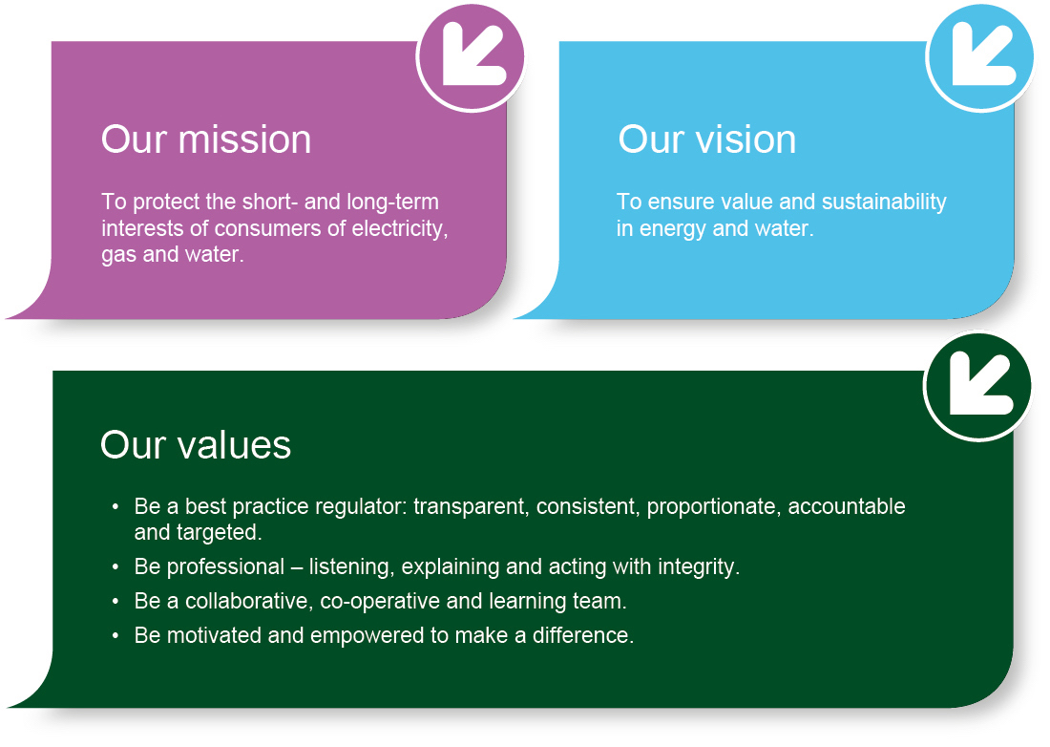
We are based at Queens House in the centre of Belfast. The Chief Executive leads a management team of directors representing each of the key functional areas in the organisation: Corporate Affairs, Markets and Networks. The staff team includes economists, engineers, accountants, utility specialists, legal advisors and administration professionals.
Contents page
Executive Summary 1
1. What is the Utility Regulator doing? 2
What is the Utility regulator doing? 2
2. Energy Supply 3
Could coronavirus impact the supply of energy to me? 3
3. Energy issues and home visits 4
What should I do if I have an energy problem? (e.g. power cut, gas leak, your bill or energy meter problem) 4
What should I do if my Supplier/Network company needs access to my property and I am self-isolating? 5
4. Prepayment customers 7
How can I top up my prepayment meter if I am self-isolating? 7
5. Affordability issues 8
What should I do if I am struggling to pay my bills? 8
6. Further help 9
I’m not sure who my energy supplier is. Who should I contact? 9

Executive Summary
This is an information leaflet for energy consumers. It covers managing your energy if you are self-isolating at home (such as prepayment energy meter top ups), what to do if you have an energy issue and information on what to expect from your supplier or network company.

What is the Utility Regulator doing?

What is the Utility regulator doing?

We are working closely with government, other stakeholders and the electricity and gas sectors to ensure all the necessary steps are being taken to serve consumers, particularly people in vulnerable circumstances and people who may need to self-isolate at home.

The Utility Regulator has plans and procedures in place with both energy Supply companies and Network companies to ensure continuity of supply for both electricity and gas.

Energy Suppliers and Network companies are expected to closely monitor and follow the most up to date government guidance, and take timely decisions on how to best protect consumers and staff, while delivering their services. They are already doing this.

If you have any questions about your own situation, contact your energy supplier in the first instance. If your issues are non-urgent please use email and web chat as telephone lines will be busier than usual. You can find their contact details on a recent bill or their website, or use the following link on the Consumer Council’s website.

If you (or someone you know) is in a vulnerable position of pensionable age, has a disability, or chronic illness it is important you let your (or their) energy supplier know. Each Supplier also keeps a Customer Care Register of people who may require additional assistance. This service is free to all consumers who are eligible.

Energy Supply

Could coronavirus impact the supply of energy to me?

No. Your energy supply won’t be disrupted, and all Suppliers and Network companies are still working to the same rules and obligations we have put in place to ensure continuity of supply.

We know that the response to the coronavirus situation may need to change quickly. We are in constant contact with government departments, suppliers, other industry participants and consumer groups so we can act to protect you if any problems arise.

We expect energy Suppliers to continue delivering good customer service and consider how best to respond to consumers particularly vulnerable consumers, in a timely manner while following the most up to date government advice. Please check websites for the most up to date information on how best to get in touch with your Supplier or use the following link on the Consumer Council’s website.

Energy issues and home visits

What should I do if I have an energy problem? (e.g. power cut, gas leak, your bill or energy meter problem)

If you experience a power cut, please contact NIE Networks:

Telephone: 03457 643 643

Visit: https://www.nienetworks.co.uk/power-cuts/power-cut

If there’s a serious immediate emergency risk, call the emergency services too.

If you smell gas or suspect a gas leak:

Turn off the gas supply at the meter, unless the meter is located in a cellar or basement in which case do not enter

Extinguish all naked flames and do not smoke or strike any matches

Open doors and windows for ventilation

Do not turn on or off any electrical switches including door entry systems

Check gas appliances to see if the gas has been left on unlit or if a pilot is out

Call the Northern Ireland gas emergency number 0800 002 001 (please do not use a mobile phone in the vicinity of a suspected gas leak)

If you have a problem relating to your energy bill or meter, you should contact your energy Supplier straight away. If your issues are non-urgent please use email and web chat as telephone lines will be busier than usual. Check websites for the most up to date information on how best to get in touch with your Supplier or use the following link on the Consumer Council’s website. Make sure to tell them if you are unwell or self-isolating.

Suppliers and Network Companies are implementing measures to deal with emergency home visits. They are monitoring government advice and will take timely decisions on how to best protect customers and staff, while delivering their services.

If you (or someone you know) is in a vulnerable position of pensionable age, has a disability, or chronic illness it is important you let your (or their) energy supplier know. Each Supplier also keeps a Customer Care Register of people who may require additional assistance. This service is free to all consumers who are eligible.

Contact the Consumer Council for Northern Ireland if you need additional help with an energy problem – for example with your bills or meters. They are the official source for free and independent energy advice and support. Further helpful advice can also be found on the Consumer Council's website.

Alternatively you can contact the Consumer Council on:
The Consumer Council
Floor 3 Seatem House
23 Alfred Street
Belfast
BT2 8EN
Tel: 028 9025 1600
Email: info@consumercouncil.org.uk

We expect Suppliers and Network companies to have the safety, health and wellbeing of their customers, as well as their own staff, as their central priority, focussing particularly on vulnerable customers, customers at risk of going off supply, or those who have gone off supply. If you are concerned or worried about the actions of your Supplier or Network company, contact them to explain the issue straightaway.

What should I do if my Supplier/Network company needs access to my property and I am self-isolating?

In the unlikely event that your Supplier or Network company contacts you to visit your property, tell them if you are unwell or are self-isolating. If you are concerned or worried about the actions of your Supplier or Network company, contact them to explain the issue straightaway. Consumer response teams have updated their training to comply with the most recent government guidance and support customers during this period of uncertainty if they are unwell or self-isolating.

Suppliers and Network companies are putting in place plans and alternative arrangements to deal with routine activities based on government advice, such as meter readings and meter inspections. The most up to date plans will be available on the Supplier or the Network company’s website.

Suppliers and Network companies are monitoring and responding to government guidance on self-isolation and health and safety, and taking timely decisions on how best to protect customers and staff while delivering their services. We expect them to have the safety, health and wellbeing of their customers as well as their own staff as their central priority, with a particular focus on risks to vulnerable customers or where customers are at risk of going off supply or have gone off supply.

If you (or someone you know) is in a vulnerable position of pensionable age, has a disability, or chronic illness it is important you let your (or their) energy supplier know. Each Supplier also keeps a Customer Care Register of people who may require additional assistance. This service is free to all consumers who are eligible.

Contact the Consumer Council for Northern Ireland if you need additional help with an energy problem. They are the official source for free and independent energy advice and support. Go to www.consumercouncil.org.uk/consumers or call them on 0800 121 6022. Calls are free.

Prepayment customers

How can I top up my prepayment meter if I am self-isolating?

Electricity suppliers offer automated top-up options via online or over the phone. We encourage you to top up online if you are able to use this option.

If you have a gas prepayment meter and are unable to top up, you may want to arrange for a trusted person to take your gas top-up card to the shop if needed. If your gas meter box is outside, you may also have to arrange for the trusted person to unlock your meter box in order to top-up. Make a list of trusted neighbours, friends and family who live nearby, and might be able to top up your card and meter if you cannot leave your home.

You can also refer to the most up to date guidance on your Supplier’s website or use the following link on the Consumer Council’s website. Suppliers should tell you:

what customer service support is available, particularly if you are vulnerable

how you might get further advice and/or support if you can’t top up or could go off supply.

We are also working with the Department for the Economy, CCNI and the Department for Communities to enable gas prepayment consumers who are self-isolating or ill to access local community support to help them top up their meter.

If your local top up shop closes, contact your supplier who can help. Paypoint.com (gas only) and Payzone.co.uk list alternative vendors online, and the Post Office also provide top ups for some Suppliers.

All Suppliers have a ‘Code of Practice on Services for Customers with Prepayment Meters’ which can be viewed on their websites or requested directly.

The Consumer Council has published additional guidance for consumers on their website to in relation to the coronavirus outbreak. Please visit their website for further guidance: https://www.consumercouncil.org.uk/coronavirus

Affordability issues

What should I do if I am struggling to pay my bills?

Information on the employment and financial support announced on 20 March is available on GOV.UK. This includes the Universal Credit, Employment and Support Allowance and your rights if your hours are cut or you are laid off.

Customers are encouraged to provide your own reads to NIE Networks (automated meter reading service) or your supplier (if you are not sure how to do this, please contact your supplier). This will ensure you are only billed for what you use and are not billed on an estimate.

If you think you can’t afford to pay for your gas or electricity supply contact your Supplier for support and advice; they can also refer you to other advice giving agencies. Suppliers are committed to working sympathetically with their customers on a case by case basis if they are experiencing difficulty paying their bills at this time.

Your Supplier must take into account how much you can afford, and will explain your options. Your Supplier has a Code of Practice for Payment of Bills, which sets out their responsibility when dealing with customers who are experiencing payment difficulties. You can request this free of charge or find it on the Supplier’s website.

If after contacting your Supplier you need further help, contact the Consumer Council or Advice NI:
The Consumer Council
Floor 3 Seatem House
23 Alfred Street
Belfast
BT2 8EN
Tel: 028 9025 1600
Email: info@consumercouncil.org.uk

Advice NI
First Floor
Forestview
Purdy’s Lane
Belfast
BT8 7AR
Tel: 028 9064 5919
Email: info@adviceni.net

Further help

I’m not sure who my energy supplier is. Who should I contact?

Please refer to your last bill or statement or your Paypoint/Payzone receipt for details of who your supplier is.

For electricity, if you have your meter point number (known as an MPRN a 17 digit number), which you can also find on a bill, you can contact NIE Networks to check who the supplier is.

Gas is slightly different as it is split into three different distribution areas. If you live in the Greater Belfast area, your supplier will either be SSE Airtricity Gas Supply or firmus energy. If you live in the Ten Towns area, your gas supplier is firmus energy and in the West of Northern Ireland, your supplier will be SSE Airtricity Gas Supply.

We have provided a table below listing all of the domestic and I&C electricity and gas supply companies, in addition to the network companies in NI.
Electricity Suppliers | Electricity Network Operator
Power NI | NIE Networks
SSE Airtricity
Electric Ireland
Budget Energy
Click Energy
Go Power
Naturgy
3T Power

Gas Suppliers | Gas Network Operators
SSE Airtricity | Phoenix Natural Gas (Greater Belfast)
firmus energy | firmus energy (Ten Towns)
Electric Ireland | SGN Natural Gas (West)
Flogas
Go Power
Naturgy

The full contact details for the Supply and Network companies is on the Utility Regulators website - https://www.uregni.gov.uk/utility-suppliers-and-contact-information or use the following link on the Consumer Council’s website.

