Schedule 11

The Procedure for the
Provision and Rejection
of Change of Supplier Readings
and the Use of Change of
Supplier Readings for
Daily Metered Supply Meter Points
and for
Very Large Daily Metered Supply Meter Points

Version: 1.6

Date: 02 April 2019

Contents

- Introduction…………………………………………………………………………..……3
1.1 Background…………………………………………………………….……...3

- Procedure for Provision and Agreement of CoS Meter Reads………………………3
2.1 Provision of CoS Meter Reads……………………………………………..3
2.2 Rejection Process for CoS Meter Reads……………………………….…4
2.3 Agreement of Notional Reads………………………………………...…....4

- Procedure for Billing of CoS Reads……………………………………………….……5
3.1 Consistent Billing of CoS Reads……………………………………..….... 5
3.2 Purpose of Consistent Billing…………………………………………....…5

Appendix 1 – Sample DM/VLDM CoS Read Provision Form……………………...……6

Appendix 2 – Sample DM/VLDM Confirmation of Agreed Notional Read Form……...7

1 INTRODUCTION
1.1 Background
There is no requirement under the Distribution Network Codes for the provision, validation, or use of CoS meter readings for Daily Metered (DM) Supply Meter Points or for Very Large Daily Metered (VLDM) Supply Meter Points.

2 PROCEDURE FOR PROVISION AND AGREEMENT OF COS METER READS

Where a Proposing User submits a Supply Meter Point Confirmation which becomes effective for a Daily Metered Supply Meter Point or a Very Large Daily Metered Supply Meter Point, paragraphs 2.1 to 2.3 (inclusive) shall apply.

2.1 Provision of CoS Meter Reads
2.1.1 The Proposing User shall secure that a valid meter reading (an ‘Opening Meter Reading’) is obtained from the Daily Read Meter referred to above:
a) for a Meter Read Date within the required date range (in accordance with paragraph 2.1.2); and
b) adjusted to reflect the Meter Reading of the Daily Read Meter on the SMP Registration Date in accordance with paragraph 2.1.3; and
c) provided to the Withdrawing User not later than 16:00 hours on the 11th Business Day after the SMP Registration Date using the DM/VLDM CoS Read Provision Form (See Appendix 1).
2.1.2 For the purposes of paragraph 2.1.1(a), the required date range is the period of 3 Business Days commencing on, and including, the SMP Registration Date. The Proposing User shall endeavour to read the Daily Read Meter as close as possible to 5:00am on any date within the required date range.
2.1.3 For the purposes of paragraph 2.1.1(b), the meter reading should be adjusted to reflect the Meter Reading of the Daily Read Meter on the SMP Registration Date by the following method:
a) If the Opening Meter Reading is taken on the SMP Registration Date, then no adjustment will be made to the Meter Reading.
b) If the Opening Meter Reading is taken on a date after the SMP Registration Date (up to 2 Business Days after the SMP Registration Date), then the actual daily consumption⁽¹⁾ as provided by the Network Operator to the Proposing User shall be deducted from the Meter Read for each day after the SMP Registration Date. This will produce a Meter Reading deemed to be taken on the SMP Registration Date which should be provided to the Withdrawing User. When providing the CoS Meter Reading to the Withdrawing User, the Proposing User will provide the actual meter read taken, date of read and the daily consumption figures that have been deducted (where applicable).
- The Network Operator provides the actual daily consumption to the Registered User of each DM Supply Meter Point and each VLDM Supply Meter Point on D+7.

2.2 Rejection Process for CoS Meter Reads
2.2.1 The Withdrawing User has two business days from receipt of the DM/VLDM CoS Read to validate the meter reading and respond to the Proposing User if they wish to reject the meter reading. The Withdrawing User should respond to the Proposing User by completing the relevant section of the DM/VLDM CoS Read Provision Form (see Appendix 1).
2.2.2 If within two business days of receiving the Opening Meter Read, the Withdrawing User notifies the Proposing User that it rejects the Opening Meter Read, then paragraph 2.3 shall apply. If the Withdrawing User does not respond to the Proposing User within 2 business days of receiving the Opening Read, it shall be deemed that the Withdrawing User accepts the Opening Read.
2.2.3 In a SoLR event, the SoLR is not required to agree an opening meter read with the defaulting Supplier. Section 7.26 of the Retail Market Procedure for Supplier of Last Resort events in the Northern Ireland Gas Industry will apply.

2.3 Agreement of Notional Read
2.3.1 A Notional Meter Read (in accordance with paragraph 2.3.2) will be required where:
a) an Opening Meter Reading is not provided to the Withdrawing User by the date required under paragraph 2.1.1(c); or
b) the Proposing User receives a rejection notice pursuant to paragraphs 2.2.1 & 2.2.2.
2.3.2 A Notional Meter Reading must be agreed between the Withdrawing User and the Proposing User based on the previous meter readings and daily consumption data held by both Suppliers. Where a Notional Meter Reading is required paragraphs 2.3.3 to 2.3.6 (inclusive) shall apply.
2.3.3 If a Notional Meter Reading is required in accordance with paragraph 2.3.1(a) the process should continue as follows:
a) if the Proposing User has been unsuccessful in securing a valid meter reading within the required date range referred to in paragraph 2.1.2, then the Proposing User should make contact with the Withdrawing User within two business days of the end of the date range referred to in paragraph 2.1.2 to advise that they could not obtain a valid meter reading and the reason why they could not obtain a valid meter reading and to initiate the agreement of a Notional Meter Read; or
b) if the Withdrawing User has not received an Opening Meter Read within the timeframe referred to in paragraph 2.1.1(c), and the Proposing User has not made contact with the Withdrawing User in accordance with paragraph 2.3.3(a), then either the Proposing User or the Withdrawing User should make contact with the other Supplier within two business days from the end of the Meter Read provision timeframe referred to in paragraph 2.1.1(c) to initiate the agreement of a Notional Meter Read.
2.3.4 If a Notional Meter Reading is required in accordance with paragraph 2.3.1(b) the process should continue as follows:
a) the Proposing Supplier must contact the Withdrawing User within two business days from the end of the read provision window referred to in paragraph 2.1.1(c) to initiate the agreement of a Notional Meter Read.
    - Within five business days from a Supplier initiating the Agreement of Notional Meter Read process as referred to in paragraphs 2.3.3 & 2.3.4, the Withdrawing User and Proposing User must agree a Notional Meter Reading to be used as the CoS Meter Read. Both the Withdrawing User and Proposing User should share details on any recent Actual Meter Readings that they hold as well as daily consumption data in order to agree a Notional Read that is deemed to be taken on the SMP Registration Date.

    - When a Notional Meter Reading has been agreed for the CoS Read, the Proposing User must ensure that this reading is confirmed to the Withdrawing User within two business days of the agreement being reached by completing and submitting the DM/VLDM Confirmation of Agreed Notional Read Form (See Appendix 2).

3 PROCEDURE FOR BILLING OF COS READS

3.1 Consistent Billing of Cos Reads
Suppliers should bill CoS reads based on the following:
3.1.1 In situations where an Actual CoS read has been provided by the Proposing User and has not been rejected by the Withdrawing User, then the meter reading provided should be used by both the Proposing User and Withdrawing User to generate the customer’s first and final bills respectively.
3.1.2 Where a Notional CoS read has been agreed by the Proposing and Withdrawing Users, then the Notional meter reading provided should be used by both the Proposing User and Withdrawing User to generate the customer’s first and final bills respectively.
    - In exceptional circumstances the Proposing User or the Withdrawing User may decide not to use the CoS read provided to generate the customer’s first or final bill respectively as long as the customer is not negatively affected.
  - Purpose of Consistent Billing
3.2.1 Following this process for billing CoS reads will provide clarity to the customer as the CoS reads on the final and first bills will be consistent. This process will also ensure that the customer will not be overcharged by either Supplier due to overlapping CoS meter reads.

APPENDIX 1 - SAMPLE dm/VLDM COS READ provision form
This is a sample of the form which would be sent by the Proposing User to advise the Withdrawing User of the DM/VLDM CoS Read and allow the Withdrawing User to accept or reject the CoS Read provided.
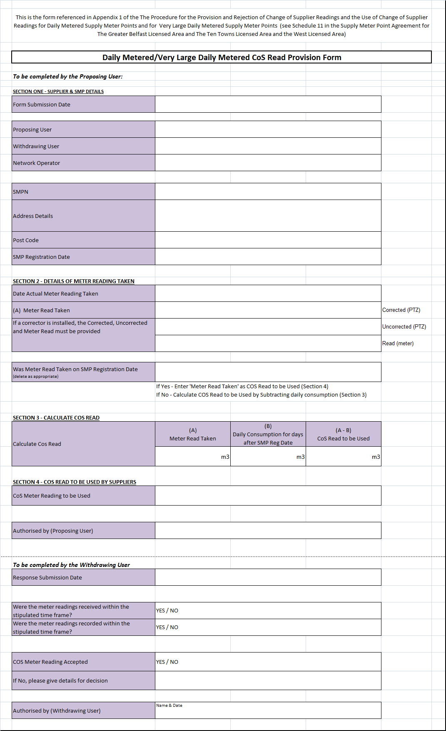

appendix 2 – sample dm/VLDM confirmation of agreed notional read form
This is a sample of the form which would be sent by the Proposing User to the Withdrawing User to confirm the Notional Meter Reading that has been agreed between Suppliers.
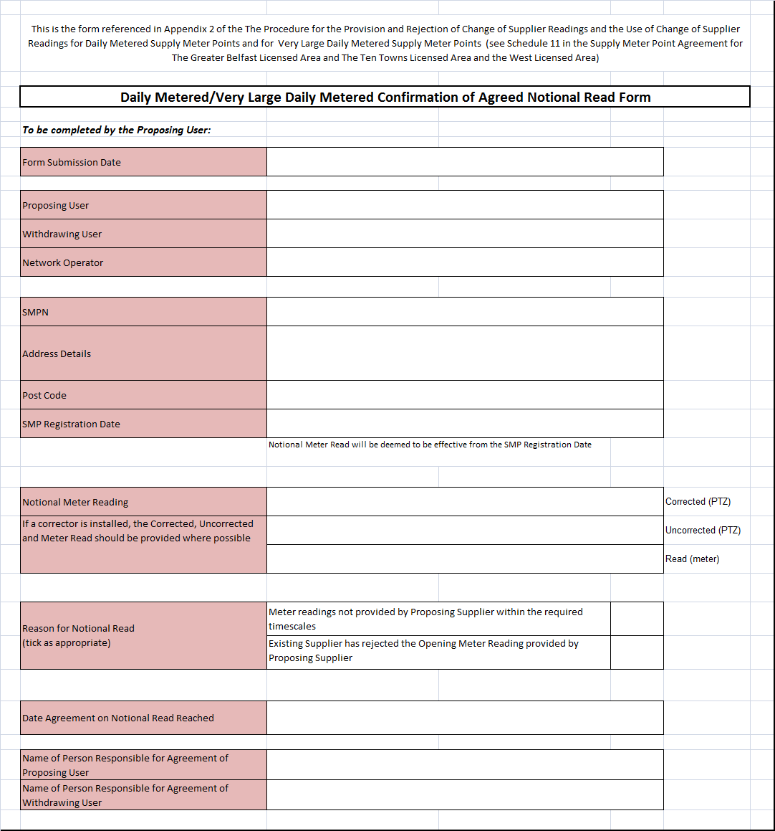

This document applies to Daily Metered (DM) supply meter points and to Very Large Daily Metered (VLDM) supply meter points. Daily Metered (DM) supply meter points exist in the Greater Belfast, Ten Towns and West areas; however Very Large Daily Metered (VLDM) supply meter points only exist in the West area.

