Schedule 13

Gas Supplier Process for Treatment of Suspected Meter Mix-Ups

02 April 2019

1.0 Introduction

1.1 Under The Gas (Individual Standards of Performance) Regulations (Northern Ireland) 2014, a Meter Mix-Up occurs where, physically, a gas meter is supplying a different Supply Meter Point (SMP) than is recorded on the Network Operator’s Supply Meter Point Register and the customer(s) is being incorrectly billed by the Gas Supplier as a result. (For example, meter 1 should be supplying Supply Meter Point 1 and meter 2 should be supplying Supply Meter Point 2. However, in reality meter 1 is supplying Supply Meter Point 2 and meter 2 is supplying Supply Meter Point 1 which results in the customer at one or both Supply Meter Points being incorrectly billed as a result).

1.2 The process undertaken by Gas Suppliers with the Network Operator for the investigation and determination of whether a Meter Mix up has occurred will be outlined in the relevant Network Operator’s procedures. Prior to the Network Operator determining that a Meter Mix-Up has occurred it will be referred to as a ‘Suspected Meter Mix Up’.

1.3 The purpose of this Schedule 13 is to detail the process Gas Suppliers must follow for investigating a Suspected Meter Mix Up when the Supply Meter Points involved have different Registers Users assigned.

1.4 In a SoLR event, or following such an event, if a meter mix up is identified and confirmed the SoLR should reconcile the customer account from the date they became the Registered Supplier.

1.5 A Suspected Meter Mix-Up normally involves two or more properties.

1.6 A Suspected Meter Mix-Up may be identified by either:
- The Registered User;
- The Proposing User;
- The Network Operator; or
- The customer.
1.7 All gas suppliers agree that they shall co-operate to resolve any identified Suspected Meter Mix-Up as soon as reasonably possible.

1.8 It should be noted that it is possible for a Gas Supplier to identify instances where, physically, the gas meter is supplying a different SMP than that recorded on the Network Operator’s Supply Meter Point Register, however, the customer has not been billed incorrectly as a result. Where a Gas Supplier identifies such instances the Distribution Network Code obliges the Gas Supplier to report any inaccuracy in the Network Operator’s Supply Meter Point Register as soon as possible. The Gas Supplier should use the relevant Network Operator’s reporting process for this purpose.

2.0 Notification

2.1 Within 5 working days of a Registered User or a Proposing User becoming aware of the existence of a Suspected Meter Mix-Up they shall complete a ‘Suspected Meter Mix-Up Notification Form’ (see Appendix 1 for a copy of this form).

Where a Network Operator identifies a Potential Meter Mix Up it will advise the Registered Users at the effected SMPs using its own reporting process

2.2 The Suspected Meter Mix-Up Notification Form shall include the following details:

- Identity of the party raising the Meter Mix-Up Notification Form;
- Date;
- Supply Meter Point Reference Numbers believed to be involved in the Meter Mix-Up;
- Meter reading;
- Meter serial number (and meter module number, where applicable);
- Address (including postcode) of Supply Meter Points believed to be involved in the Meter Mix-Up; and
- Initial indication, if possible, of the correct Supply Meter Point details.

2.3 The party raising the Suspected Meter Mix-Up Notification Form shall send the completed form to the Registered User of each Supply Meter Point involved.

2.4 In circumstances where the identity of the Registered User of a Supply Meter Point is unknown the relevant Network Operator may be requested to request the Registered User to contact the supplier raising the Suspected Meter Mix-Up Notification Form.

2.5 Upon receipt of the Suspected Meter Mix-Up Notification Form the Registered User of each Supply Meter Point involved agree to co-operate in order to resolve the Meter Mix-Up.

3.0 Communication with the Customer

3.1 Either on confirmation of a Suspected Meter Mix-Up or where the cooperation of a customer is required in respect of a Meter Mix-Up the Registered Users of the Supply Meter Points involved shall inform the customer of the following:

- A Suspected Meter Mix- Up or a Meter Mix-Up may or has occurred which involves their Supply Meter Point;
- What is being done to resolve the issue;
- The impact the resolution of the Meter Mix-Up process may have on their billing arrangements (e.g. may result in a debit or credit to their account);
- Request their co-operation in resolution of the Suspected Meter Mix-Up as it may be necessary to gain access to their property to complete a Consumption Check; and
- Inform the customer they may receive a reconciliation bill or credit from their previous gas supplier.
- Inform the customer they will receive a payment from the Network Operator in line with the requirements of the GSS Regulations post confirmation that a Meter Mix-Up has occurred.

4.0 Consumption Check

4.1 Often with Suspected Meter Mix-Ups it is necessary to complete a Consumption Check at each property involved in order to ascertain with certainty which meter is supplying which Supply Meter Point.

4.2 Suppliers agree to co-operate with each other to organise Consumption Checks at the earliest possible opportunity, where required.

4.3 The customers associated with the Supply Meter Points involved normally need to be present in order for a Consumption Check to be completed. The Registered User of each Supply Meter Point involved in the Suspected Meter Mix-Up undertakes to communicate with their customer in respect of scheduling a Consumption Check.

4.4 The Registered User will confirm the date and time of the Consumption Check with the customer in writing.

4.5 The Registered User of each Supply Meter Point involved in the Suspected Meter Mix-Up will make available a company representative to attend and carry out the Consumption Check at the Supply Meter Point registered to them at the date and time agreed.

5.0 Meter Readings

5.1 It will often be the case that the Registered User of a Supply Meter Point involved in a Suspected Meter Mix-Up will have read and retain the meter readings for a Supply Meter Point which they do not supply.

5.2 Each supplier agrees to provide the meter readings they retain in respect of a Supply Meter Point involved in a Suspected Meter Mix-Up with the Registered Users of the other Supply Meter Points involved in the same Suspected Meter Mix-Up.

5.3 When providing the meter readings the Register User shall provide the following details:
- Supply Meter Point Reference Number;
- Supply Meter Point Address;
- Supply Meter Point Postcode;
- Meter Serial Number;
- Meter Module Number (if applicable);
- All meter readings retained for the meter;
- Date of all meter readings;
- Whether the meter reading is an actual, estimated or customer meter reading.

6.0 Account Reconciliation

6.1 Each Registered User shall be responsible for reconciling the gas account for which they are the Registered User based on the meter readings obtained under Section 5.

6.2 Where a Supply Meter Point has been supplied by more than one gas supplier the previous gas supplier shall be responsible for reconciling the gas account of the customer for the period in which they supplied the customer. This may result in the customer receiving a bill or credit from their previous gas supplier. In a SoLR event, this paragraph will not apply.

7.0 Notification to Network Operator

7.1 Once the Registered User(s) has completed its investigations into the Suspected Meter Mix-Up it should notify the Network Operator of its investigation in line with the Network Operator’s procedure Appendix 1

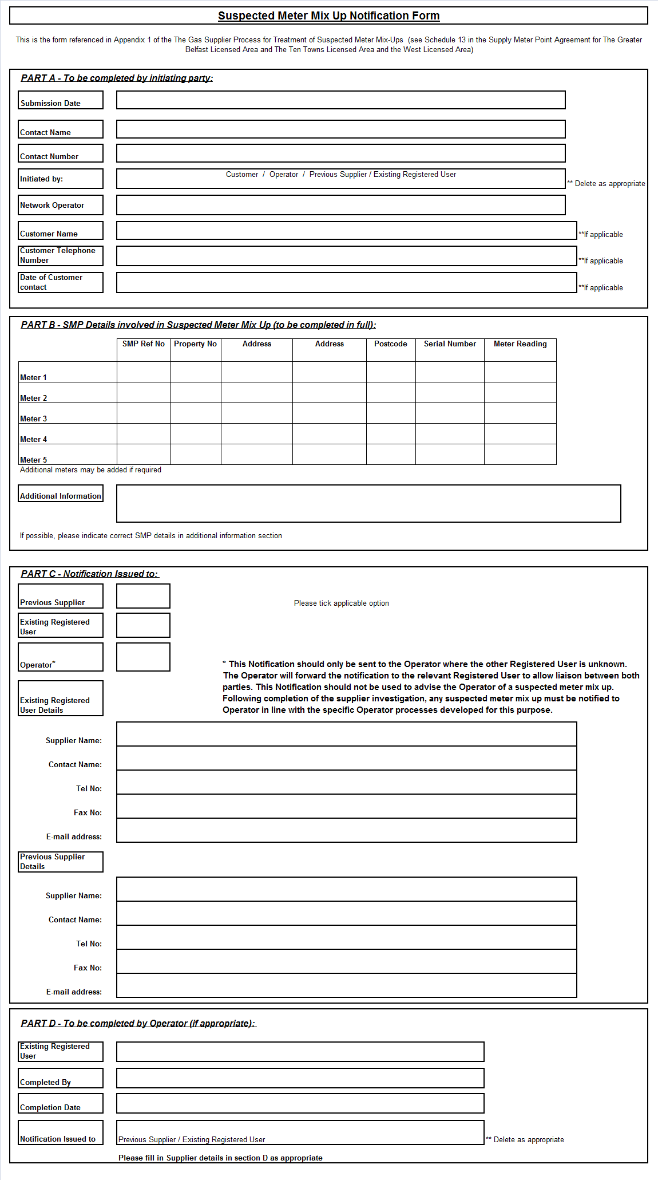

http://www.legislation.gov.uk/nisr/2014/60/contents/made

