Schedule 17

Domestic
Customer Switching

Retailer Code of Practice for
Dealing with Quantum Customers
wishing to Switch Supplier

Version date: 02 April 2019

Contents

1 Background and Definitions 3

2 Purpose 4

3 Scope 4

4 Procedures 5

5 Timeline 7

6 Appendix 1 8

7 Appendix 2 9

1.0 Background and Definitions

This Code of Practice aims to provide a consistent transparent and non-discriminatory framework to facilitate customers with Quantum Meters to switch supplier.

In this Code of Practice, unless the context otherwise requires the following capitalised words and phrases have the following meaning:

“Aged Debt” is the term as defined in the "Retailer Code of Practice for Dealing with Customers in Debt wishing to Switch Supplier";

"Change of Supplier" or "COS" means the application by a customer to obtain a supply of gas from a Proposing Supplier in relation to his premises;

"CQO1" or "CQO5" or "CQO8" or "CQO9" means the forms submitted to Siemens Metering Services to update and amend customer details.

"Credit Balance" means the monetary value of credit remaining on the Quantum Meter on the SMP Registration Date.

"Data Protection Legislation" means the Data Protection Act 1998 as amended and all applicable laws and regulations relating to the processing of personal data and privacy, including where applicable the guidance and Codes of Practice issued by the Information Commissioner;

"Debt" is the term as defined in the "Retailer Code of Practice for Dealing with Customers in Debt wishing to Switch Supplier";

"Proposing User" means a supplier requested by the customer to supply gas to his premises in substitution for the Withdrawing User;

"Quantum Customer" means a customer supplied with natural gas by means of a Quantum Meter;

"Quantum Database" means the database of Quantum Customer records maintained by Siemens Metering Services for all Quantum Customers in the United Kingdom;

"Quantum Meter" means a meter by which gas can be paid for in advance and through which debt can be collected;

"Siemens Metering Services" or "SMS" means the organisation that manages and operates the Quantum System on behalf of gas suppliers in the United Kingdom;

“SoLR” means Supplier of Last Resort

"Withdrawing User" means the incumbent supplier who is supplying gas to a customer at a particular premise;
2.0 Purpose

This document is intended to:

- describe standards of good practice and service in dealing with the transfer of customers with Quantum Meters;

- promote the disclosure of information, between relevant gas suppliers, on switching customers that are supplied through a Quantum Meter;

- promote informed and effective relationships between suppliers and their customers;

- achieve a smooth and seamless supply point and supplier transfer process for customers who are supplied through a Quantum Meter; and

- ensure customers fulfil their obligations to their supplier and pay for the gas which they consume.

The document outlines the procedures required to facilitate switching suppliers for Quantum Customers.

3.0 Scope

The scope of this document is limited to domestic Supply Meter Points being supplied through a Quantum Meter and gas suppliers who are licenced to supply within the Greater Belfast Licence area and who have acceded to the Supply Meter Point Agreement.

This process is only applicable if both the Existing Registered User and the Proposing User have entered an ‘Agreement for the Provision of Quantum Services’ with Siemens Metering Services.

Where a Proposing User has not entered an ‘Agreement for the Provision of Quantum Services’ with Siemens Metering Services they shall not be entitled to supply customers through a Quantum Meter.

In a SoLR event Annex 7 – SoLR Prepayment Processes, as outlined in the Retail Market Procedure for Supplier of Last Resort events in the Northern Ireland Gas Industry, will apply.

4.0 Procedures

4.1 Information Sharing

All suppliers agree (and give permission) that Siemens Metering Services may provide a full list of all Quantum reference numbers to any supplier who has entered into an ‘Agreement for the Provision of Quantum Services’ with Siemens Metering Services and who have acceded to the Network Code and have acceded to the Supply Meter Point Agreement.

4.2 a: Debt

Where a Quantum Customer is in Debt (as defined in the "Retailer Code of Practice for Dealing with Customers in Debt wishing to Switch Supplier") the procedures outlined in the "Retailer Code of Practice for Dealing with Customers in Debt wishing to Switch Supplier" shall apply.

4.2 b: Aged Debt

An aged debt notification form should be completed for each quantum customer switching supplier (as defined in the "Retailer Code of Practice for Dealing with Customers in Debt wishing to Switch Supplier")

4.3 Outstanding Balance

The term "Outstanding Balance" is defined as follows:

Where the customer has failed to pay charges for the supply of gas or any other supply charges to those premises or any premises previously owned or occupied by him in respect of which such charges are payable which:

- Are due to the Existing Registered User and have been demanded in writing; and
- Have remained unpaid for 28 days after the bill has been issued; and
- Do not exceed one hundred pounds (£100).

Where a Quantum Customer has an Outstanding Balance the Outstanding Balance shall not be transferred between the Existing Registered User and the Proposing User.

The Proposing User shall be entitled to recover the Outstanding Balance from the Quantum Customer.

4.4 Credit Balance

Where a credit balance exists, an agreed average for the credit balance remaining on a Quantum Meter at the SMP Registration Date must be transferred between the Existing Registered User and the Proposing User. Appendix 1 outlines this procedure. This agreed average credit figure is set at £18.00 per quantum meter switch: however, this figure is subject to review.
The Quantum Customer shall not be entitled to a refund as they will be supplied to the value of the credit balance on the Quantum Meter at the SMP Registration Date by the Proposing User.

4.5 Transfer of Quantum Customer

The Proposing User shall ensure that a CQO1 form is submitted to Siemens Metering Services which will instruct Siemens Metering Services to programme a Quantum gas card with supplier and customer specific information. This allows the customer to be transferred from the Existing Registered User to the Proposing User on the Siemens Metering Services Quantum Database.

The Proposing User shall ensure that the CQO1 form is only submitted:
- Once the objection period has ended; and
- In the case of the Quantum Customer having Debt, when all processes in relation to Debt have been finalised in accordance with the Retailer Code of Practice for Dealing with Customers in Debt wishing to Switch Supplier; and
- No sooner than 6 Working Days prior to the SMP Registration Date.

The Existing Registered User may also submit a CQO9 form to Siemens Metering Services requesting the closure of the Quantum Customer record on the Siemens Metering Services Quantum Database. The Existing Registered User shall not submit a CQO9 to Siemens Metering Services prior to 7 Working Days prior to the SMP Registration Date. Note that it is not essential for the Existing Registered User to submit a CQO9 form to Siemens Metering Services to ensure the transfer of the customer to the Proposing User.

5.0 Timeline
The following diagram shows the various timescales associated with the transfer of a Quantum Customer to the Proposing User.

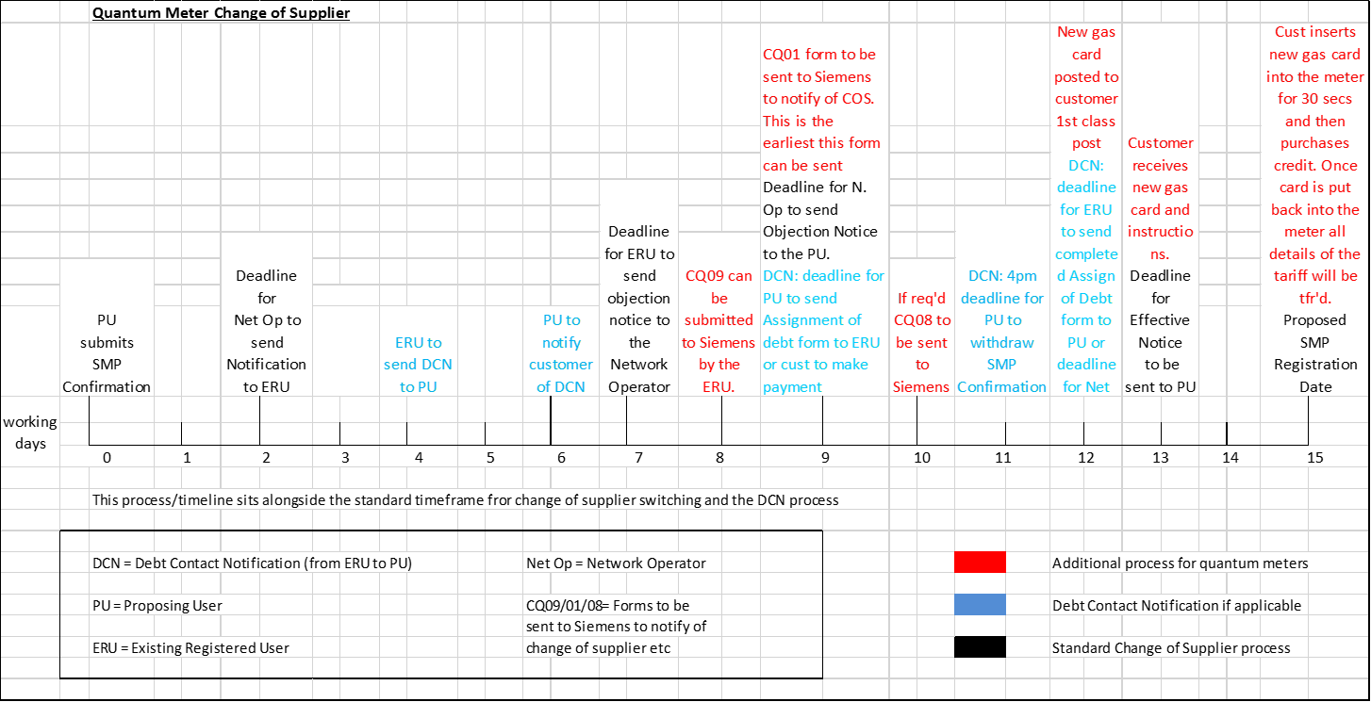

Appendix 1:

Where a credit balance exists, an agreed average credit balance for each quantum meter at the SMP Registration Date may be claimed by the registered user from the withdrawing user. This agreed average credit figure is set at £18.00 per quantum meter switch: however, this figure is subject to review.

The registered user will calculate the number of quantum switches with SMP Registration dates within the last calendar month. This figure should tally with the records held by the withdrawing user.

The number of quantum switches is to be multiplied by the agreed average figure. However, if there is a debt balance on the meter which belongs to the current occupier of the property and is recoverable through the meter, no credit claim is made for this quantum switch. Any recoverable debt figure is to be deducted from the total credit claim being made by the registered user.

Worked example for the credit transfer for quantum meter customers:

a * b = c Key:
c – d = e a: Number of quantum customers with an effective date in
e & VAT = f the last calendar month, not including any customers that have a recoverable debt on the meter
b: Agreed figure of average credit balance per quantum meter switch
c: Initial value of credit claim for quantum customers with an effective date in the last calendar month
d: Value of recoverable debt on quantum switches that became effective in month
e: Net value of credit to be claimed from the withdrawing user
f: Value of credit (inc VAT) to be claimed from the withdrawing user

For clarity, the number of customers and the collectable debt must be for customers that became effective within the same calendar month.

For example:
In a given calendar month there are 100 quantum customers with an effective date for that month
The agreed average credit balance is £18.00
2 of the customers that became effective within the given month had a debt balance totalling £30.00

98 * £18.00 = £1,764.00
£1,764.00 - £30.00 = £1,734.00
£1,734.00 + 20% VAT = £2,080.80 to be claimed from the withdrawing user

Appendix 2

Claims Procedure

Each supplier would draw up claims on another supplier on a monthly basis. Disputed claims should be raised within one month of receiving claims, and the disputed amount paid within one month of the dispute resolution.

There will be no lower limit for individual supplier-to-supplier claims.

For the purposes of validation, each claim must be supported by workings, provided by the registered user. These workings will be sent at least one month in advance of any payment due and should be presented in a spreadsheet format.

