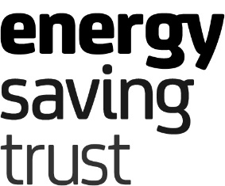
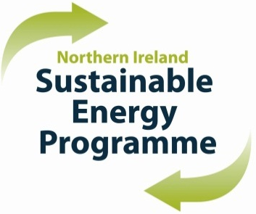

Northern Ireland Sustainable Energy Programme 2022-23

Call for Schemes – Registration

TO BE SUBMITTED BY 14 OCTOBER 2021

Primary Bidder

I confirm that the above is registered as a NISEP primary bidder and wishes to receive a submission pack in order to propose schemes for consideration for the 2022-23 NISEP year.

Please indicate below the approximate number of each type of scheme you are considering submitting:

Priority Whole House Solution
Priority Individual
Priority Innovative
Non-priority Conventional
Non-priority Innovative

If a scheme indicated above includes the install of renewable technology, please insert the technology below, so that additional information is included in the submission pack, if applicable:

_______________________________________________________________________________

Please submit this form by email to NISEP@est.org.uk

Failure to submit this form by 14 October 2021 may result in your submissions being rejected

Print Name
Job Title
Date
Contact Email Address
Contact Telephone No.

