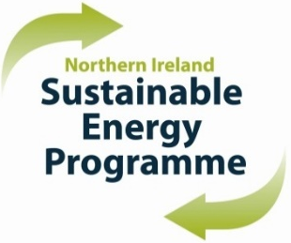
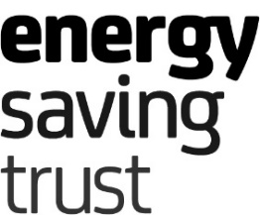

Northern Ireland Sustainable Energy Programme 2025/27

Primary Bidder Registration Form

This registration form must be completed to register your interest in applying to become a Primary Bidder with the NISEP Programme Administrator. Please ensure you have read and fully understand the eligible criteria outlined in section 1.4 of the NISEP Framework Document. The most recent NISEP Framework Document 2023/25 can be found here). The 2025/27 NISEP Framework Document will be published at the end of September 2024 and the criteria is subject to change. You must be able to meet all criteria to be granted Primary Bidder status.

Company Name: __________________________________________________

Company Address Line 1: _____________________________________________

Company Address Line 2: _____________________________________________

Company Address Line 3: _____________________________________________

Company Address Line 4: _____________________________________________

Company Registration Number: __________________________________________

I confirm that the above company wishes to apply for Primary Bidder status. I confirm that I have read and can fully meet the criteria, including the technical soundness criteria, as stated in the current NISEP Framework Document 2023/25.

I am interested in bidding for the following types of schemes should the application be successful. Please select more than one type of scheme if appliable.

 | Priority Whole House Solution (WHS) |  | Priority WHS - Innovative
 | Priority Individual Measures |  | Priority Social Housing provider (SHP)
 | Non-Priority Conventional Domestic / Commercial |  | Non-Priority - Innovative

Print name:
Job Title:
Date:
Contact Email Address:
Contact Telephone No:

Please submit this form by email to NISEP@est.org.uk by 31 July 2024 and Energy Saving Trust (Programme Administrator) will provide further details of the registration process.

Failure to submit this completed form by 31 July 2024 will mean your registration to become a NISEP Primary Bidder will not be progressed any further.

