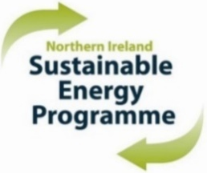
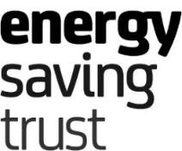

Northern Ireland Sustainable Energy Programme 2027/29

Call for Schemes – Registration Form

TO BE SUBMITTED BY 23 OCTOBER 2026
Primary Bidder:

I confirm that the above is registered as a NISEP Primary Bidder and wishes to receive a submission pack to propose schemes for consideration for the 2027/29* NISEP years.

*Approved schemes will run for two full NISEP years, subject to satisfactory performance in year 2027/28 and criteria defined in the Framework Document being met. To clarify, there will be no ‘call for schemes’ for 2028/29. In addition, as per section 2.3 of the Accedence Agreement, the Utility Regulator may, at its sole discretion and without cause, elect that Approved Schemes shall end at the expiry of the first year, 2027/28, (31 March 2028).

Please indicate below the approximate number of each scheme type, as listed in the 2027/29 NISEP Framework Document, that you intend to submit for funding:

 | Priority Individual Measures |  | Priority Whole House Solution (WHS)
 | Priority WHS Innovative |  | Priority Social Housing Provider Individual Measures
 | Priority Social Housing Provider Innovative |  | Priority Social Housing Provider WHS
 | Non-priority Domestic Conventional |  | Non-priority WHS Innovative Domestic
 | Non-priority Commercial / Non-Domestic

If you intend to submit a WHS Innovative Scheme, please indicate below the approximate number of schemes that will include at least one of the innovative measures listed below:

 | Air Source Heat Pump |  | Solid Wall Insulation |  | High Heat Retention Electric Storage Heaters

If you have indicated a Social Housing Provider scheme above, please detail the intended scheme offering below:

Please submit this form by email to NISEP@est.org.uk

Failure to submit this form by 23 October 2026 may result in your submissions being rejected

Print Name
Job Title
Date
Contact Email Address
Contact Telephone No.

