Northern Ireland Electricity plc

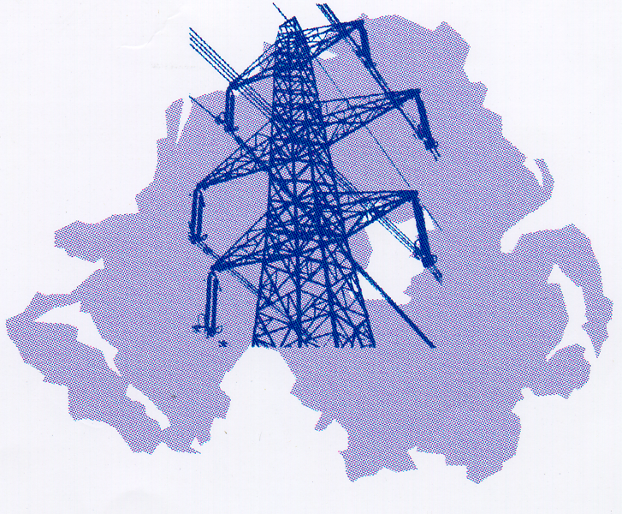

Bulk Supply Tariff


2006/07
Power Procurement Business
NIE POWER PROCUREMENT BUSINESS

Bulk Supply Tariff 2006-07

  - Introduction

This Bulk Supply Tariff ("BST") has been published by Northern Ireland Electricity plc ("NIE") in accordance with the requirements of the Transmission Licence (the "Licence") granted to NIE pursuant to Article 10 of the Electricity (Northern Ireland) Order 1992 (the "Order").

For the purposes of this BST

Bulk Supply Tariff Agreement means an agreement between NIE and a Relevant Supplier providing, inter alia, for the payment by the Relevant Supplier of charges levied under this BST;

Generating Unit Agreements means the agreements between NIE and generating companies for the provision to NIE of the whole or any part of the available capacity and output of individual generating units;

Interim Settlement Arrangements means the arrangements established under the Licence for settlement of imbalances arising out of trading under bilateral contracts between generating companies and Relevant Suppliers, including the Interim Settlement Code and the Interim Settlement Agreements;

kW means kilowatts;

kWh means kilowatt hours;

Point of Supply means the point on the NIE System at which electricity supplied to a Relevant Supplier is metered in accordance with its Bulk Supply Tariff Agreement;

Power Station Agreements means agreements between NIE and generating companies which deal with certain aspects of the operation of the power stations; and

"Relevant Supplier" means a person who has entered into a Use of System Agreement with NIE and who is either (i) a person authorised by a licence granted pursuant to Article 10 (1)(c) or (10)(2) of the Order or (ii) a relevant exempt self supplier within the meaning of the Electricity (Class Exemptions from the Requirement for a Licence) Order (Northern Ireland) 1999.

Settlement Period means a period of thirty minutes starting on, or thirty minutes after, the hour;

The ‘charges’ set out in this BST include all the provisions set out in this BST.

A fee of £5.00 is payable for each copy of this Bulk Supply Tariff statement.
  - Summary of Wholesale Electricity Charges

    - There are some system related costs which were previously part of the Bulk Supply Tariff which are now separately identified as System Charges and which are charged on all electricity supplied in Northern Ireland. These System Charges relate to System Support Services (SSS) and Public Service Obligations (PSO) and are described in paragraph 9.

    - The components of charges to a Relevant Supplier purchasing from NIE under this BST will be:

(i) Capacity Charges
(ii) Unit Rate Charges (including Fuel Cost Adjustment)
(iii) System Charges
(iv) Administration Charges.

    - In relation to electricity traded through the Interim Settlement Arrangements, under the terms of the Interim Settlement Arrangements, Relevant Suppliers will pay System Charges in respect of all electricity they supply to eligible customers.

The Interim Settlement Arrangements also provide for Relevant Suppliers and generating companies to pay the Capacity Charges and Unit Rate Charges for electricity provided under those arrangements.

3. Relevant Suppliers

Each Relevant Supplier purchasing under this BST shall pay NIE for electricity supplied in the year ending 31st March 2007 in accordance with the following charges, provisions, rates and adjustments. The BST is available for bulk supplies of electricity and is a long-term arrangement. The registration requirements under the BST Agreement are designed to be consistent with this.

4. Supplier's Chargeable Units

For the purposes of calculating the Unit Charges payable by each Relevant Supplier pursuant to paragraph 10, and the other System Charges pursuant to paragraph 9, the Supplier's Chargeable Units in any Settlement Period shall be the aggregate of the number of kWh supplied to the Relevant Supplier at each Point of Supply (as determined by metering installed in accordance with the Relevant Supplier's Use of System Agreement) multiplied by the appropriate adjustment factor for that Point of Supply (as set out in paragraph 6).

5. Supplier's Demand

For the purposes of calculating the Capacity Charges payable by each Relevant Supplier pursuant to paragraph 7, the Supplier's Demand in any Settlement Period (expressed in kW) shall be equal to twice the Supplier's Chargeable Units for that Settlement Period (as determined in accordance with paragraph 4).

6. Adjustment Factors

For 2006/07 the adjustment factor for each Point of Supply is determined by reference to the voltage at which electricity is supplied to the Relevant Supplier at that Point of Supply in accordance with the following table:

Voltage at which Adjustment
electricity is supplied Factor

275 kV 1.011
110 kV 1.020
33 kV 1.039
11 kV 1.062
6.6 kV 1.062
0.4 kV or less 1.114

7. Capacity Charges

Each Relevant Supplier shall pay, in accordance with paragraph [15], a Capacity Charge which is equal to £36 multiplied by the Supplier's Chargeable Peak Demand.

The Supplier’s Chargeable Peak Demand means the average of the Supplier's Demand during each of the Peak Settlement Periods identified in paragraph 8.

8. Peak Settlement Periods

The Peak Settlement Periods referred to in paragraph 7 are defined as the Settlement Period of the highest total system demand (in terms of units sent out) for each winter weekday in the period 20th November 2006 to 19th February 2007 inclusive (excluding the period 25th December 2006 to 1st January 2007 inclusive) and falling between 16.00 hrs and 19.00 hrs on those days.

9. System Charges

There are two elements to the System Charges :

- System Support Services (SSS)
- Public Service Obligation (PSO)

These charges will be as published for 2006/07.

10. Unit Charges

The Supplier’s Chargeable Units in relation to a Relevant Supplier, for each Settlement Period shall be charged at the appropriate rate taken from the following tables :

Summer Period 1 April 2006 - 31 October 2006

Days and Times Rate Days and Times Rate
Applicable p/kWh Applicable p/kWh

Saturdays, Sundays & Non Public Holiday
Public Holidays Weekdays

00.00-00.30 2.854 00.00-00.30 2.894
00.30-06.00 2.856 00.30-05.30 2.957
06.00-08.00 2.915 05.30-08.00 3.108
08.00-14.00 4.375 08.00-13.00 6.808
14.00-16.30 3.825 13.00-18.30 6.062
16.30-23.00 3.942 18.30-23.00 4.045
23.00-24.00 3.031 23.00-24.00 2.959

Winter Period 1 November 2006 - 31 March 2007

Days & Times Rate Days & Times Rate Days & Times Rate
Applicable p/kWh Applicable p/kWh Applicable p/kWh

Sats, Suns, Mons-Fris Mons-Fris
Public Holidays 20 Nov-19 Feb 1 Nov-19 Nov
& 25 Dec-1 Jan Inclusive. 20 Feb-31 Mar
Inclusive. Inclusive.

00.00-01.00 3.310 00.00-01.00 3.291 00.00-01.00 3.265
01.00-03.30 3.191 01.00-06.30 3.281 01.00-06.30 3.243
03.30-08.00 3.201 06.30-08.00 3.710 06.30-08.00 3.621
08.00-13.00 5.043 08.00-12.30 7.816 08.00-12.30 7.207
13.00-16.30 4.794 12.30-16.30 7.418 12.30-16.30 6.838
16.30-21.00 5.907 16.30-18.30 10.116 16.30-18.30 8.660
21.00-24.00 3.625 18.30-20.30 7.283 18.30-20.30 7.089
20.30-22.30 5.363 20.30-22.30 5.133
22.30-24.00 3.733 22.30-24.00 3.575

Note: The summer unit rates are based on £77/Cet and the winter unit rates at £87/Cet for Fuel Price Adjustment purposes.
11. Fuel Price Adjustment

In each calendar month during which this BST is applicable, the Unit Charge rates set out in paragraph 10 shall be adjusted by 0.010 p/kWh for each £0.25 by which the Reference Fuel Cost per coal equivalent tonne in the relevant month (rounded to the nearest £0.25) differs from £77.00 in the summer period (April to October) and from £87.00 in the winter period (November to March).

The Reference Fuel Cost per coal equivalent tonne is estimated each month by NIE in the relevant month and corrected to take account of any differences between actual and estimated costs not taken into account for any month previous to the relevant month during which this BST is applicable.

The Reference Fuel Cost per coal equivalent tonne is equal to the sum of the total Energy Charges (including Fuel Stocking payments) payable by NIE to generating companies under Generating Unit Agreements and Power Station Agreements. This net total is then divided by the number of coal equivalent tonnes that generating companies are deemed to have burned during that month in carrying out instructed operations (calculated on the basis of the gross calorific value of the Despatched Fuels and the Energy Allowances set out in the Generating Unit Agreements and an assumed gross calorific value per coal equivalent tonne of 26.0 gigajoules) .

- Large Customer Tariff Discount (Preserved Terms)

The Large Customer Tariff Discount (LCTD) has been discontinued but will be preserved in respect of Supplies for the same customers in respect of which the LCTD was applied in 2005/06. Terms remain available where a Relevant Supplier supplies a customer whose demand exceeds one MW in any Settlement Period and whose electricity is supplied at its Point of Supply at a voltage of 33kV and the customer was supplied under the LCTD terms in 2005/06. In that case a discount of 10% shall be applied to those charges set out in paragraphs 7 and 10 above.

13. Administrative Charges

Each Relevant Supplier shall pay to NIE a charge of £42 per month, on the basis of processing one total data set for that supplier. It is the responsibility of the Relevant Supplier to ensure that the metered data is presented in the appropriate form.

14. Value Added Tax

Value added Tax, at the rate ruling at the time of supply, will be applied to all charges made under this BST.

15. Payments

Invoices will be issued on a monthly basis within 14 days of the end of each month and payment is required 10 business days after receipt of the invoice.

Interest will be charged on overdue accounts on a daily basis at a default rate which is three percentage points per annum above the base lending rate of Bank of Ireland Ltd.

For Capacity Charges, an estimate is made of the likely annual charge, either by agreement with NIE or on the basis of the previous year's Chargeable Peak System Demand, and 3% of the estimated charge is included in each of the invoices for the months April to October and March, with 19% included in the invoices for November, December, January, and February. Truing-up ignoring interest will occur on the March invoice.

To satisfy credit-worthiness, NIE may require any Relevant Supplier to give reasonable security by way of a deposit, bond or otherwise as agreed with NIE, for payment of all monies which may become due to NIE.

16. Effective Date

This BST shall take effect on 1st April 2006

February 2006

Northern Ireland Electricity plc
Registered Office
120 Malone Road
Belfast BT9 5HT
Registered in N. Ireland NI 26041

