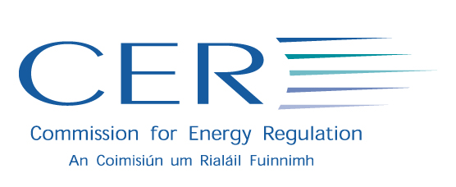
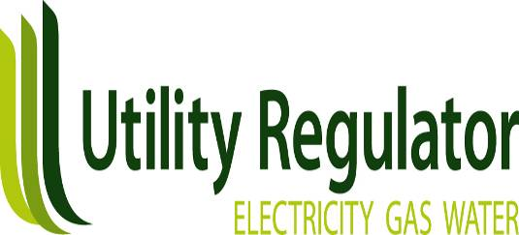

PRESS RELEASE 11.04.07
For Immediate Release

Energy Regulators Agree Strategy for further
All-Island Cooperation

The two energy regulators (CER and NIAUR) on the island of Ireland have today announced details of a joint strategy for delivering further liberalisation and competition in electricity on an all-island basis.

The Commission for Energy Regulation (CER) and NIAUR (Northern Ireland Authority for Utility Regulation have signed a Memorandum of Understanding (MOU) setting out a programme of agreed measures for the further strategic development of all island electricity markets. This strategy will build upon the groundbreaking Single Electricity Market (SEM) for the island of Ireland which is due to commence on 1 November of this year.

This initiative enhances cross border cooperation in the energy sector building upon the strong links which have been built up between the two Regulatory Authorities since 2004. The key aim of this initiative is to ensure the delivery of competition and the equal treatment of customers and market participants regardless of their location on the island.

The new cross-border strategy outlines the following objectives:

- The two Regulatory Authorities have a shared objective of ensuring effective competition for all electricity customers on the island. No one company should have greater than 40% market share.
- The CER will work with ESB to ensure the phased divestment/closure of 1,500 MW of ESB generation by 2010. This strategy is referred to as the CER-ESB Asset Strategy Agreement.
- The operation of electricity transmission lines will be made completely independent of companies operating in the competitive markets, in both jurisdictions, by November 2008 at the latest. This has been achieved in Ireland, with the formal establishment last year of EirGrid plc as the independent transmission system operator (ISO) and plans are now well advanced to formally establish SONI Ltd. as ISO in Northern Ireland.
- Work to promote retail market competition and choice for all customers will be re-doubled. As competition strengthens, the Regulatory Authorities will phase out tariff regulation.
- The Regulatory Authorities will work to ensure the liquidity of the new wholesale electricity market (the SEM).
- The two bodies will apply a consistent, transparent and harmonised approach to market regulation on the island. This includes standardised arrangements to allow customers to switch supplier, standardised codes of practice and a common approach to the regulation of companies such as ESB and NIE.

The Memorandum of Understanding was signed by the Energy Regulators on 22 March 2007. The Regulators are confident that it sets out the correct strategy for the development of an all island electricity market that will support competition in the interests of customers. A copy of the signed MoU can be viewed on the website of the all island project (www.allislandproject.org) and also on the CER website (www.cer.ie) and the NIAUR website (www.ofreg.nics.gov.uk).

ENDS

For further information, please contact:

Conall McDevitt Chris Brown
Senior Director, Weber Shandwick Account Manager, Weber Shandwick
T: 028 90 761 007 T: 028 90 764 924
M: 07770886933 M: 07770886911
E: cmcdevitt@webershandwick.com E: chbrown@webershandwick.com

Note to Editors:

The CER and the NIAUR signed a Memorandum of Understanding on 23 August 2004 committing the two organisations to working together towards the development of an All Island electricity market. The Single Electricity Market (SEM) is the first step in this project. The Single Electricity Market (SEM) is the establishment of new wholesale electricity trading arrangements for the island of Ireland. The SEM market will go-live on 1 November 2007. Further details are available on the website of the All Island Energy Market Project, www.allislandproject.org.

This MOU has been signed as an addendum to the MOU of 23 August 2004. The following are the signatories;

Tom Reeves, Michael G. Tutty Iain Osborne,
Chairman, Commissioner, Chief Executive,
CER CER NIAUR

