

NIE Networks Transmission and Distribution price control (RP6) draft determination

Submission by Prospect Utility Regulator, Electricity, Gas, Water

19 May 2017

www.prospect.org.uk

Introduction
- Prospect welcomes the opportunity to respond to the draft determination NIE Networks Transmission and Distribution price control (RP6). Prospect is the trade union representing 500 professional engineers and managers working in the electricity sector in Northern Ireland.
- Our response will focus on Regional Wage Adjustment and the regulator’s proposal that this should be 88% of the UK average figure. Prospect is extremely concerned at the detrimental effect this will have on NIE’s ability to keep pace with labour costs in the energy sector.
- The analysis by Cambridge Economic Policy Associates Ltd (CEPA) relies on national ASHE data without taking into account compositional differences across the economy. Meaningful labour market comparisons are difficult unless adjustments are made for factors such as job content, age, gender, qualification and skill levels. London is the highest paying region within the UK because a high proportion of its labour force is employed in high-paying industries and occupations and because many employees are entitled to allowances for working in the capital. As a result of this the Regional Wage Adjustment figure is set too low. When London data is excluded the average level of pay in Northern Ireland is 97% of the average weekly wage in the rest of the UK.
- There are particular pressures on recruiting and retaining skilled engineers in the energy sector. These pressures are exacerbated by the demographic challenges that all DNOs will face in the next 10 years. The current methodology used in RP6 does not include a specialist labour premium which would take account of the difficulty of recruiting and retaining skilled labour in the sector.
- We would also query the restrictions on investment, in particular the request for major IT investment by NIE. The recent global cyber attack underlines the importance of these systems to utilities like NIE and the vulnerability of old IT systems. Restrictions on investment will inevitably mean that it will be more difficult for NIE to deliver appropriate IT systems in a timely way.
Regional Wage Adjustment
- When setting the Regional Wage Adjustment (RWA) it is important that comparisons are meaningful. The dataset used by CEPA does not differentiate between different groups of workers and so it is difficult to know how to evaluate the data. For example a greater proportion of employees with higher qualifications will tend to work in better paid jobs in London and the South East. These compositional differences help to explain the difference in pay levels between Northern Ireland and the rest of UK. What it will not help to do is make a judgement about the appropriate level of pay in the energy sector.
- The RP6 does not take into account the actual experience of NIE and other DNOs. As the draft determination shows the level of regional pay is not an important factor for energy companies when deciding where to locate their workforce. However this is not reflected in the methodology chosen to compare pay.
- The inclusion of those working in London pushes up the average rate of pay overall. When London data is excluded the difference between average pay in Northern Ireland and other UK regions narrows to just 3% (see the Table below). There is still a pay lead in the South East and Eastern region over other regions, but the overall difference is not as great.
Median full-time gross weekly earnings by region, April 2016
 | Earnings (£) | %
North East | 494.0 | 96.8%
North West | 503.2 | 98.6%
Yorkshire and The Humber | 498.3 | 97.7%
East Midlands | 483.2 | 94.7%
West Midlands | 510.2 | 100.0%
East | 528.8 | 103.7%
South East | 566.0 | 111.0%
South West | 505.0 | 99.0%
Wales | 492.4 | 96.5%
Scotland | 535.0 | 104.9%
Northern Ireland | 495.2 | 97.1%
Average | 510.12
ONS: ASHE
- Pay pinch points are starting to emerge in the economy. As the Bank of England Agents report observes; “recruitment conditions had tightened a little further, with skills shortages reported in a wider range of activities.” This will increase the premium of workers with specialist skills in the energy sector.
- Several studies have identified Northern Ireland as having a particular issue with attracting skilled labour. The UKCES Employer Skills Survey found that Northern Ireland had higher vacancy rates in the energy and utilities sector than anywhere else in the UK, while the CBI in Northern Ireland has warned that “more than half of businesses in Northern Ireland fear they will not be able to recruit enough high-skilled workers to succeed in the future” and the problem is especially acute in STEM sectors. Imposing an RWA that fails to take account of the particularities of the Northern Ireland energy sector would only serve to keep pay levels artificially low, exacerbating an already acute skills shortage.
Prevalence of vacancies in companies in the energy and utilities sector (Source: UKCES Skills Survey 2013)
 | UK | England | Wales | Scotland | Northern Ireland
Vacancies (%) | 12.5 | 12.9 | 12.4 | 9.0 | 14.0

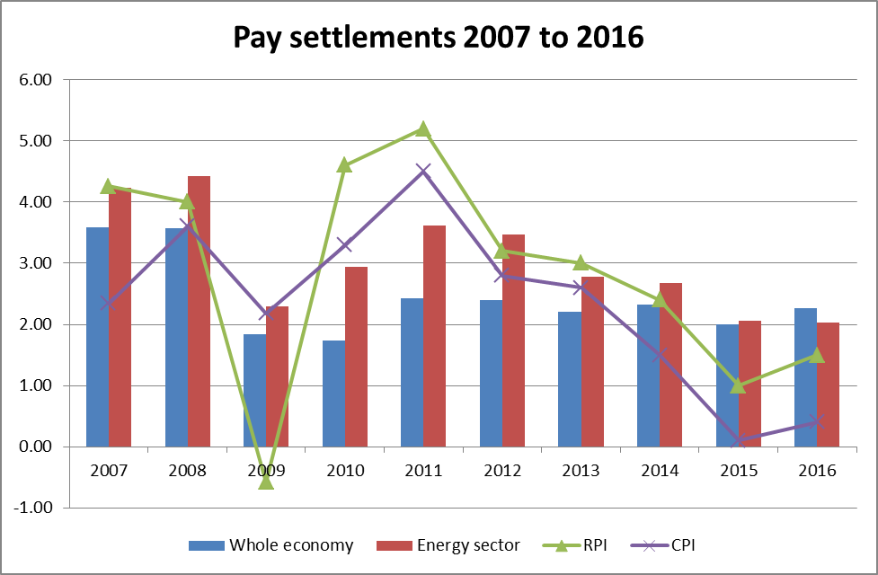
- Pay settlements in the energy sector have kept pace with inflation over the last 10 years. NIE competes for labour in this market and so pay rates have to remain competitive. The Table below shows the difference between pay levels in the whole economy and the Energy and Water sector. These rise significantly in more senior roles.
Source: Prospect, IDR and XpertHR
Salary Levels (Professional Engineering Grades)
Job Level | Whole Economy | Energy & Water | Difference | % Difference
Level 5 | £26,638 | £28,446 | £1,808 | 6.36%
Level 6 | £33,625 | £41,140 | £7,515 | 18.27%
Level 7 | £42,556 | £53,480 | £10,924 | 20.43%
Level 8 | £56,338 | £67,782 | £11,444 | 16.88%
Source: Income Data Research – Pay Benchmarker
- Brexit is likely to exert an upwards pressure on wages. The Bank of England note that although EU migrants are not leaving the UK a number of companies report difficulty in recruiting new migrant workers. Any reduction in the supply of labour is likely to increase the value of the skilled workers’ premium.

Agents Summary of Business Conditions, Bank of England May 2017 http://www.bankofengland.co.uk/publications/Pages/agentssummary/default.aspx
Annex J, First Economics, page 9
“Skills crisis in Northern Ireland threatens local growth” CBI Northern Ireland, 6 August 2015 (http://cbi.binarydev.net/news/skills-crisis-in-northern-ireland-threatens-local-growth-cbi-pearson-survey/)

