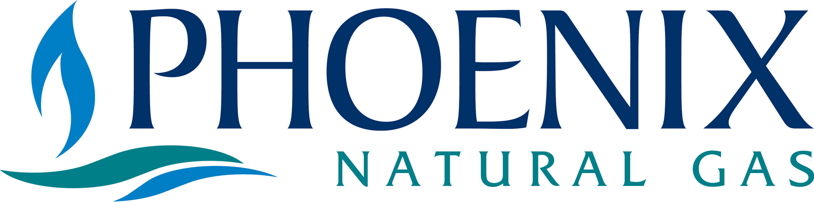

Lisa Mullan
Ofreg
Queens House
10 – 18 Queen Street
Belfast
BT1 6ED

28 October 2005

Dear Lisa,

Re: Energy Efficiency: The “Most Best” Options

Thank you for providing Phoenix with this opportunity to respond to the above. We are encouraged by Ofreg’s focus to improve the mechanisms by which Northern Ireland can become more energy efficient.

Indeed, over the last decade or so, natural gas has been one of the major contributors to reducing greenhouse gas emissions. Since 1997, we estimate that over one million tonnes of CO₂ has been removed from the local atmosphere. In 2005 alone, we calculate that over 270,000 tonnes of C0₂ will be removed. This equates to removing around 80,000 small family sized cars from local roads – in one year alone!

Phoenix welcomes this opportunity to provide its views in relation to the following proposals.

- The case for a major expansion of energy efficiency expenditure.

Phoenix welcomes any expansion of energy efficiency expenditure. The Warm Homes programme has been successful in tackling fuel poverty in households where the elderly, on passport benefits, live. However, with any extension of energy efficiency expenditure, Phoenix would like to see an extension to the Warm Homes and Warm Homes Plus schemes whereby the criteria could be extended to say, families with young children and to remove the eligibility criteria for the over 60’s.

- Moving to a target based approach rather than a budget constrained approach.

Phoenix would welcome a target based approach.

Indeed, Phoenix has worked closely with Northern Ireland Electricity (NIE), Northern Ireland Housing Executive (NIHE), Energy Saving Trust (EST), Eaga Partnership and the Department for Social Development (DSD) to deliver a range of targeted initiatives.

This approach has proved very successful and has assisted households who were in receipt of Family Tax Credits, Housing Associations via the Cosy Homes initiative and those with inefficient systems, as part of the Energy Efficiency Plus scheme, to install high efficiency gas condensing systems. We have calculated that 2,000 households have been “fuel poverty proofed” via these initiatives.

- Creating a single Climate Change Fighting Fund which would be a single funding source for energy efficiency and renewable energy measures.

Phoenix would welcome such a fund and believe that NIE would be ideally suited to manage the day to day operation of the fund with the support of Ofreg, similar to the current arrangements for governing the Energy Efficiency Levy.

- Raising the money for the fund from a mixture of sources.

Phoenix believes that an extension to the EEL, on an average per customer level, is the most equitable approach. We would therefore support any proposal to increase the EEL to the equivalent GB level of £15 per customer.

- Introducing a £6,000 per dwelling connection charge with massive rebates for dwellings which reach high standards of sustainability.

Phoenix would welcome the opportunity to consider this further with Ofreg.

- Expanding the SMART budget by £1m each year on the previous year.

Given the long term savings derived by schemes funded as part of the SMART programme, Phoenix supports any proposal to increase the SMART budget between 2005 and 2010.

- Incentivising energy suppliers to become dual or multi-fuel ESCo’s.

Phoenix would welcome the opportunity to consider this approach with Ofreg.

- Developing divergent approaches for existing and new-build.

Phoenix would welcome the opportunity to consider this further with Ofreg.

- Exploring the scope for inducing behavioural change and creating market mechanisms which would incentivise companies to seek behavioural change.

Phoenix is already engaged with a number of key stakeholders in bringing about significant behavioural change in the way we heat our homes and self-generate electricity. Phoenix would like to see further support coming from government to promote traditional CHP projects, and to assist in funding a major domestic CHP initiative within the Greater Belfast gas licence area. This technology needs government ‘pump-priming’ to overcome the upfront capital cost of DCHP. In Great Britain, £15 per household is set aside for energy efficiency schemes. Northern Ireland will require similar levels of funding if we are to make DCHP a reality and if we are able to fund innovative energy efficiency solutions.

It is also essential that the oil, LPG and coal industries are encouraged to act responsibly, by statute, as the gas and electricity industries are, to undertake environmental and energy efficiency commitments to their consumers.

We also feel that Northern Ireland’s Building Regulations need to be consistent, (in relation to boiler efficiencies), with the Government’s overall environmental policy objectives. Phoenix, with the support of the EEL, continues to promote the installation of high efficiency boilers. For energy efficiency to become widely recognised in all households, it is imperative that only high efficiency boilers should be installed in future government supported energy efficiency initiatives.

Should you require any further information to the points raised, please contact me directly on 02890 555861 or by email on michael.scott@phoenix-natural-gas.com.

Yours sincerely,

Michael Scott
Senior Business Analyst

