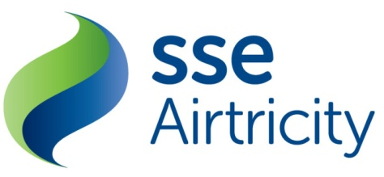

the utility regulator’s consultation on northern ireland energy’s payment security policy 2014

SSE Airtricity Response to

the utility regulator

June 2014

Introduction
SSE Airtricity welcomes the opportunity to comment on the energy payment security policy consultation 2014.
SSE Airtricity is the largest independent supplier operating in Ireland with over 800,000 customers served across both electricity and natural gas markets. SSE Airtricity is committed to the development of competition in energy markets in Northern Ireland and to presenting its customers with choice and quality customers services.

General Comments
Airtricity is fully supportive of the Payment Security Policy (PSP) contained within NIE’s licence which requires Supplies to have a ‘security cover’ in place for payments that would be due to NIE for their use of the distribution network. It is an understandable requirement to have an insurance policy to eliminate or reduce the amount NIE would have to recover directly from customers in the event of a supplier defaulting on its payments.
With this position in mind SSE Airtricity has set out some comments below on the questions requested by the UR.
Will an increase in Supplier cover be seen as a barrier to entry to new Suppliers?
SSE Airtricity currently has no views on whether an increase in cover would be viewed as a barrier to potential new suppliers.
Which of NIE’s options strikes the best balance between the risk and the cost to the consumer?
In relation to the four options presented in the paper, we would not support Option 3 – Payment Security Cover (PSC) in Line with levels required in the Republic of Ireland as it is not possible to make a like for like comparison.
This option is based on two winter months cover as NIE have indicated that customer exposure to bad debt is more significant in the winter months and therefore it is reasonable to base the payment security cover on charges in the winter months. They also stated that it allows for SEM harmonisation, aligning with the security cover provided by Suppliers to ESB Networks in ROI. We would argue that this would not in fact mirror the ROI market as there are no seasonal rate variations in place in this market, whereas in NI there are considerable increases during the winter months.
We believe that the fairest and most equitable measure would be Option 4 - PSC Equal to 2 Average Months DUoS and PSO Charges. Of the options provided this one strikes the best balance between the risk and the cost to the consumer.
Should any other options / risk cost recovery mechanisms be investigated?
SSE Airtricity currently has not produced any alternative options/risk cost recovery mechanisms.
Do Suppliers consider that the 1% charge is a ‘typical rate’ for them to provide additional cover?
We would consider that the 1% charge is a ‘typical rate’ for them to provide additional cover.
What is the realistic security cover shortfall that should be considered when reviewing the current Payment Security Cover policy?
SSE Airtricity currently has no comment on what is the realistic security shortfall.
What is the likelihood of a Supplier/Suppliers defaulting and NIE being unable to recover the debt within 6 months or earlier?
SSE Airtricity currently has no comment on the likelihood of a Supplier defaulting.

Conclusion
In conclusion, SSE Airtricity welcomes the review of the payment security policy. However, we would not support NIE’s determination that Option 3 would provide payment security cover in line with levels required in the Republic of Ireland as it is not possible to make a like for like comparison. We believe that Option 4 provided strikes the best balance between the risk and the cost to the consumer.

