**Schedule 19**

**Domestic**

**Customer Switching**

**Retailer Code of Practice for**

**Dealing with an incomplete switch for Libra PAYG Customers**

Version date: 22 September 2016

Contents

1 Background and Definitions 3

2 Purpose 4

3 Scope 4

4 Procedures 5

5 Timeline 6

6 Claims Procedures 6

7 Exceptions 7

Appendix 1 Incomplete Switch Form

Appendix 2 Timeline

Appendix 3 Sample Letter 1, 2 & 3

Appendix 4 Claims Procedure Template

**1.0 Background and Definitions**

This Interim Code of Practice aims to provide a consistent transparent and non-discriminatory framework to facilitate the transfer of Libra Pay As You Go customers who have not picked up their Change of Supplier message back to their previous Supplier. This process will run pending the development of a long term industry solution and will be subject to full review 3 months after its implementation.

In this Code of Practice, unless the context otherwise requires, the following capitalised words and phrases have the following meaning:

**"Change of Supplier Message"** or **"COS Message"** means the message downloaded to selected PayPoint outlets by the Registered User containing tariff value codes;

**"Libra Meter"** means Libra 100/110 meter by which gas can be paid for in advance;

**"Libra PAYG Customer"** means a customer supplied with natural gas by means of a Libra 110/110 Meter;

**“Previous Supplier”** means the Supplier who was the Registered User at the SMP prior to the SMP Confirmation that resulted in an Incomplete Switch

**“Proposing User”** means the Supplier who is making a SMP Confirmation which must become effective in accordance with Section L of the Network Code; and

**“Registration Date”** means the date the Supply Meter Point is registered to the Supplier in accordance with Section L of the Network Code.

**“Registered User”** means the current Supplier registered to the SMP by the Relevant Distribution Network Operator

**“Relevant Distribution Network Operator”** means the Phoenix Natural Gas ltd or firmus energy distribution who operate the relevant Distribution Network

**“SMP Confirmation”** means the statement submitted to the Relevant Distribution Network Operator to become the Registered User in respect of the Proposed Supply Meter Point

**"Withdrawing User"** means the incumbent supplier who is supplying gas to a customer at a particular premise;

**2.0 Purpose**

This document is intended to:

* describe standards of good practice and service in dealing with the transfer of Libra PAYG customers with an incomplete switch ;
* achieve a smooth and seamless supply point and supplier transfer process for customers who are supplied through a Libra Meter; and
* ensure customers fulfil their obligations to complete their PAYG switch.

**3.0 Scope**

The scope of this document is limited to domestic Supply Meter Points being supplied through a Libra Meter and gas suppliers who are licenced to supply within the Greater Belfast & 10 Towns Licence areas and who have acceded to the Supply Meter Point Agreement.

**4.0 Procedures**

**4.1 Switch**

Where a Libra PAYG Customer wishes to switch their Supplier the procedures outlined in the "Retailer Code of Practice for Dealing with Libra Pay As You Go Customers wishing to Switch Supplier" shall apply.

**4.2 Incomplete Switch**

The term "Incomplete Switch" is defined as follows:

Where the customer has failed to pick up their Change of Supplier message from the designated PayPoint and updated the Registered Users tariff values to their Libra meter. This term will apply to customers who:

1. Have not picked up their COS Message within 28 calendar days following their Registration date ;
2. Have not contacted the Registered User to advise they are experiencing issues collecting their COS message; and
3. Have not contacted the Registered User to request additional time to collect the message.

**4.3 Transfer of Libra PAYG Customer to the Previous Supplier**

The Registered User shall notify the Previous Supplier of any Incomplete Switches through submitting an Incomplete Switch form (Appendix 1) via email. The Relevant Distribution Network Operator should also be included in any email for information.

The Registered User shall ensure that the Incomplete Switch Form is only submitted:

1. Once 35 days have lapsed since the Registration Date to allow time for notification of COS Messages picked up by Libra PAYG Customers to be uploaded into the Registered Users system; and
2. Only for those Libra PAYG Customers that have not contacted the Registered User to advise that they are experiencing issues collecting their COS Message; and
3. Only for those Libra PAYG Customers that have not contacted the Registered User to advise that they would like additional time to collect their COS Message.

The Previous Supplier will submit a SMP Confirmation within 2 business days of receipt of the Incomplete Switch form. The Registration Date should be 15 Business days in the future. For the avoidance of doubt, no termination notice is required and the Registered User does not require the permission of the Libra PAYG Customer to transfer their property back to the Previous User.

**5.0 Timeline**

From the time of the COS message being available at the PayPoint terminal the Libra PAYG Customer has a 28 day window in which to pick up their COS Message and complete the switch to the Registered User on their Libra Meter.

Any customer who has not picked up their COS Message by day 14 post their Registration Date should be contacted by the Registered User to prompt the customer to pick up the COS Message (Sample Letter 1).

By day 35 post Registration Date any Libra PAYG Customer that has not picked up their COS Message shall be notified by the Registered User that they have not completed their switch on their Libra PAYG meter and therefore they will revert to their Previous Supplier (Sample Letter 2).

Day 35 post Registration Date the Libra PAYG Customer is fully deemed to have failed to complete the switch. The Registered User will send an Incomplete Switch form via email to the Previous User.

On or before day 37 post Registration Date the Previous Supplier will acknowledge receipt of the Incomplete Switch form to the Registered User and will submit a SMP Confirmation to the Relevant Distribution Network Operator.

Day 58 post Registration Date the Libra PAYG Customer will be notified by the Registered User that they are now their supplier (Sample Letter 3)

The timescales associated with the transfer back of a Libra PAYG Customer to the Previous User are as outlined in Appendix 2.

**6.0 Claims Procedures**

The Withdrawing User would draw up claims on the Proposing User using the following calculations:

Any claim associated with an Incomplete Switch will be based on an estimated consumption derived from an agreed daily profile over a 12 month period using the Withdrawing User’s appropriate tariff.  The profile for the claim would be based on the average AQ for a customer with a PAYG meter as provided by the Relevant Distribution Network Operator on an annual basis.

The dates the customer is supplied by the Withdrawing User will be entered into a V-LookUp table and an amount for the time of their incomplete switch (this being the time period between the Registration Date of the initial switch and the day prior to the Registration Date of the switch back) will be calculated.  As an agreed daily profile would be used this would offer transparency for the claim amounts.

There will be no lower limit for individual supplier-to-supplier claims. Any credit due to customers as a result of this process will be subject to the same refund arrangements that apply in Schedule 15 of the SMP Agreement.

For the purposes of validation, each claim must be supported by workings provided by the Withdrawing User. These workings should be sent at least one month in advance of any payment due and should be presented in a spreadsheet format (Appendix 4)

**7.0 Exceptions**

Where, following completion of the above listed process, a customer makes contact with either the Proposing or Withdrawing User to object to the treatment of their switch indicating they wish to complete their switch this will be addressed on a case by case basis by the Proposing and Withdrawing Users to ensure the customer is switched appropriately.

**Appendix 1:**

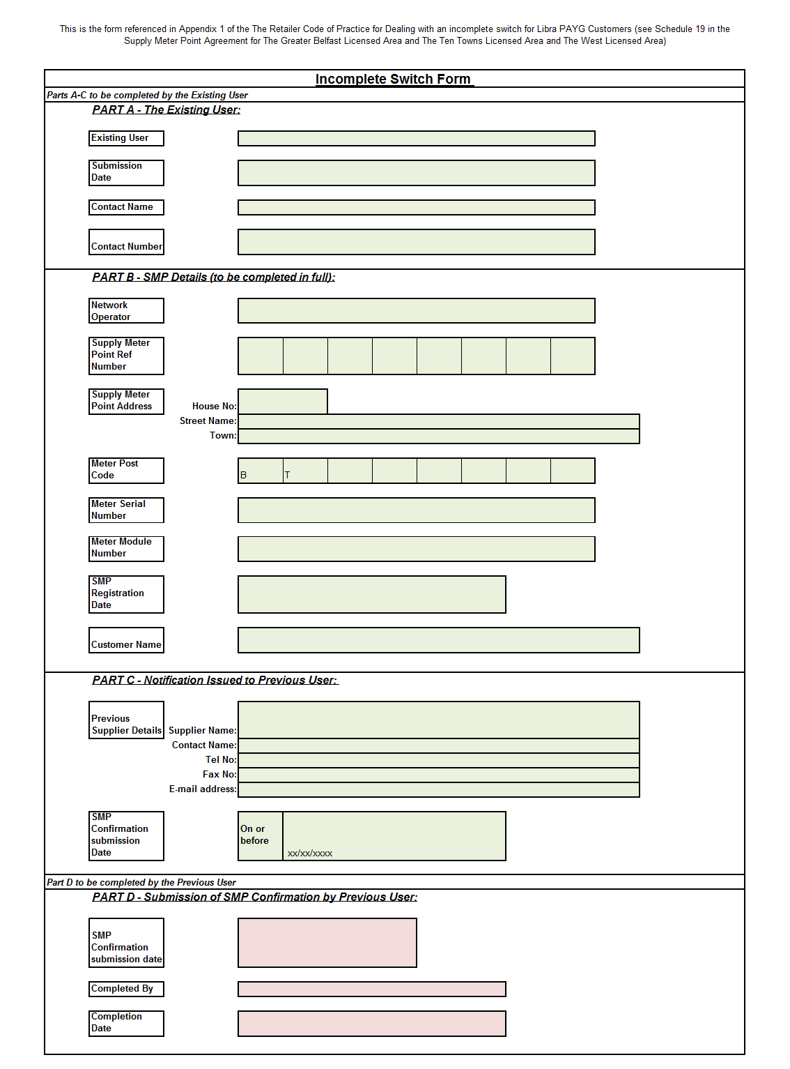

**Appendix 2:**



**Appendix 3:**

Sample letter 1

Mr A Jones

1 Test Street

Test

BT1 1XX

31st October 2013

Dear customer

Our records show that you have not picked up your change of supplier message and therefore you have not yet completed your switch to *Name of Supplier*. Until your switch is complete you will not receive the tariff you signed up for and will not be paying our prices for your natural gas.

To finalise your switch please bring your PAYG top up card to *Name of Paypoint* to pick up your switching message on or before the *xx/xx/xxxx.* For this 1st transaction please top up between £5 and £20 on your existing gas card. Failure to pick up this message will result in your account reverting back to *Name of Previous Supplier*.

If you are experiencing difficulties picking up your change of supplier message or have any queries regarding your switch please contact us on *02811 111 111* or email us on *supplier@supplier.co.uk*.

Yours sincerely

Sample letter 2

Mr A Jones

1 Test Street

Test

BT1 1XX

31st October 2013

Dear customer

Unfortunately you have not picked up your change of supplier message and as a result you have not completed your switch to *Name of Supplier*.

Your natural gas supply will be reverted to *Name of Previous Gas Supplier*.

Thank you for your interest in switching to *Supplier Name*. If you would like to process a new switch application please do not hesitate to contact us on *02811 111 111* or email us at *supplier@supplier.co.uk.*

Yours sincerely

Sample letter 3

Mr A Jones

1 Test Street

Test

BT1 1XX

31st October 2013

Dear customer

We have received confirmation from *Supplier Name* that you have not completed your switch. As a result from xx/xxxx *Previous Supplier Name* will be your natural gas supplier.

If you have any queries please do not hesitate to contact us on *02811 111 111* or email us at *supplier@supplier.co.uk*.

Yours sincerely

**Appendix 4:**

Workings to support claim for transactions made by Libra PAYG Customer during the period of their Incomplete Switch.

|  |  |  |  |  |  |
| --- | --- | --- | --- | --- | --- |
| SMP reference: | Meter Serial No: | Meter Module No: | Initial Registration Date: | Switch back Registration Date: | Claim amount |
|  |  |  |  |  |  |
|  |  |  |  |  |  |
|  |  |  |  |  |  |
|  |  |  |  |  |  |