**Schedule 7**

**Domestic Market Opening**

**and**

**Customer Switching**

**Retailer Code of Practice for**

**Dealing with Customers in**

**Debt wishing to Switch**

**Supplier**

Version: 1.11

Date: 02 April 2019

Contents

1. Background and Definitions………………………………………………………..3

1. Purpose…………………………………………………………………………….…4
2. Scope………………………………………………………………………………....4
3. Status and Adherence…………………………………………………………….…4
4. Code of Practice…………………………………………………………………..….5
   1. Part A – Disclosure……………………………………………………….…….5
   2. Part B – Principles of Conduct……………………………………………..….6
5. The Procedure………………………………………………………………….….…8
   1. Customer Agreement……………………………………………………………8
   2. Informing Customer of Debt Contact Notice………………………………….8
   3. Assignment of Debt……………………………………………………………...9
   4. Payment of Debt to Withdrawing User………………………………………...9

Appendices

Appendix A – Debt Contact Notification (DCN) scenarios and example outcomes 10

Appendix B – Debt Contact Notification (sample form) 11

Appendix C - Agreement to transfer debt (sample form) 12

Appendix D – Letter to customer confirming agreement to transfer debt (sample) 13

Appendix E – Letter to customer explaining choices to switch supplier (sample) 14

Appendix F – Timescales for transfer of debt and payment of debt 15**1. Background and Definitions**

This Code of Practice aims to provide a consistent transparent and non-discriminatory framework to facilitate customers in debt to switch suppliers. The Code of Practice also proposes arrangements for the disclosure of information between the Existing Registered User and the Proposing User where the customer is considered to have an outstanding debt with the Existing Registered User.

In this Code of Practice, unless the context otherwise requires the following capitalised words and phrases have the following meaning:

**“Aged Debt”** as defined in paragraph 5.1.

**“Change of Supplier”** or **“COS”** means the application by a customer to obtain a supply of gas from a Proposing Supplier in relation to his premises;

**“ Data Protection Legislation”** means the Data Protection Act 1998 as amended and all applicable laws and regulations relating to the processing of personal data and privacy, including where applicable the guidance and Codes of Practice issued by the Information Commissioner;

**“Debt”** as defined in paragraph 5.1;

**“Debt Contact Notification”** or **“DCN”** means the Process described in this Code of Practice for the Withdrawing User notifying a Proposing User that a customer is in Debt;

"**Existing Registered User**" is a User (who may be the Proposing User) who is the Registered User in respect of an Existing Supply Meter Point.

**"Gas Supplier":** a User who has been granted a licence for the supply of gas under Article 8(1)(c) of the Order;

**“Gas Supplier Forum”** or **“GSF”** means the body comprised of licensed natural gas suppliers;

**“NIAUR”** means the Northern Ireland Authority for Utility Regulation or its successor;

**“Proposing User”** means a supplier requested by the customer to supply gas to his premises in substitution for the Withdrawing User;

**“Quantum Meter”** means a meter by which gas can be paid for in advance and through which debt can be collected;

**“SoLR”** means Supplier of Last Resort

**“Supply Meter Point Number”** or **“SMPN”** means the unique number allocated to each meter point;

"**User**": a person, other than the Operator, who is for the time being bound by the Code pursuant to the Framework Agreement.

**“Vulnerable Customer”** means a customer who, for reasons of age, health or disability is unable to safeguard their personal welfare or the personal welfare of other members of their household;

**“Withdrawing User”** means a gas supplier who is currently supplying gas to a customer at a Supply Meter Point (SMP).

**For any terms referenced within this Schedule, but not defined above, the meaning as defined in the Network Code(s) will apply.2. Purpose**

This document is intended to:

* describe standards of good practice and service in dealing with the transfer of customers in Debt;
* promote the disclosure of information, between relevant gas suppliers, on switching customers that have a Debt;
* promote informed and effective relationships between suppliers and their customers;
* achieve smooth and seamless supply point and supplier transfer process for customers with Debt; and
* ensure customers fulfil their obligations to their supplier and pay for the gas which they consume.

The document also outlines a process for Debt Contact Notification and working procedures that will enable customers who have a Debt with the Existing Registered User, to transfer to the Proposing User as an integral part of the switching transaction.

**3. Scope**

The scope of this document is limited to domestic Supply Meter Points for gas suppliers in Northern Ireland.

In a SoLR event, an SMP may be registered to the SoLR regardless of debt owed by the customer to the defaulting Supplier. The SoLR will not be permitted to recover any debt owed by the customer to the defaulting Supplier. Section 9.1 of the Retail Market Procedure for Supplier of Last Resort events in the Northern Ireland Gas Industry will apply.

**4. Status and Adherence**

It is intended that the Debt Contact Notification process and related procedures will be contained within this document.

**5. Code of Practice**

This code is in two parts:

1. **Part A-Disclosure**

This part describes the information one supplier must provide to another supplier in respect of the transfer of customers in Debt.

1. **Part B-Principles of Conduct**

This part describes certain principles of conduct, which suppliers must follow when dealing with customers in Debt.

**5.1 Part A – Disclosure**

**Debt**

Suppliers have an obligation to help prevent customers falling into debt in the first instance and should maintain suitable arrangements for monitoring and assisting customers that have difficulty in paying their gas bills.

The term ‘debt’ is defined as follows:

Where the customer has failed to pay charges for the supply of gas or any other supply charges to those premises or any premises previously owned or occupied by him in respect of which such charges are payable which:

1. Are due to the Existing Registered User and have been demanded in writing; and
2. Have remained unpaid for 28 days after the bill has been issued; and
3. Exceed one hundred pounds (£100).

**Debt Notification**

On a Change of Supplier a credit check may be carried out. This credit check shall include asking the Existing Registered User if that customer has Debt.

For Change of Supplier requests the Existing Registered User will issue a Debt Contact Notification (see Appendix B) if the customer has Debt in accordance with the definition of debt above within 2 (two) working days of receiving a SMP Confirmation; otherwise it will be deemed that the customer has no Debt.

**Customer Notification**

The Proposing User will within 2 (two) working days of receipt of the Debt Contact Notification inform the customer in Debt of the outcome of the credit check.

**Aged Debt**

It is possible for a Quantum meter to hold an aged debt value i.e. the debt value on the meter does not belong to the current occupier of the property. The existing Registered User will issue an ‘Aged Debt’ notification (see Appendix B) for every Quantum switch within 2 (two) days of receiving a SMP Confirmation. This will confirm if there is a debt on the meter that belongs to the current occupier of the property which can continue to be recovered through the meter. For the avoidance of doubt, this applies to Quantum metered customers only.

**5.2 Part B – Principles of Conduct**

**Supplier Choices for Customers**

If it is established that the customer is in Debt, the Proposing User will offer at least one of the following options to the customer:

1. The Proposing User agrees to the transfer of the Debt from the Existing Registered User and agrees repayments terms with the customer; or
2. The Proposing User agrees to the transfer of the Debt from the Existing Registered User and agrees the installation of a Quantum meter as a means of recovering the debt from the customer; or
3. The customer is requested to repay their outstanding Debt with the Existing Registered User within 3 (three) working days, prior to the customer transfer taking place.

If the customer does not agree to one of the above options the Proposing User will withdraw the SMP Confirmation until the customer has settled the debt with the Existing Registered User.

**Supplier’s Terms and Conditions**

Each supplier will make available to a customer, a copy of their Terms and Conditions of supply upon request. It is recommended that suppliers Terms and Conditions of Supply will include relevant information on requirements contained within the Debt Contact Notification and transfer process.

**Customers with difficulty paying bills**

Suppliers will offer help for customers (particularly vulnerable customers) having difficulty paying bills. This will include offering a repayment plan to suit their budget and energy saving advice to help reduce their energy costs.

Suppliers recognise the predisposition of certain groups of vulnerability (see definition) and will pay due regard to the needs of those deemed to be vulnerable through their code of practice.

**Privacy and Confidentiality**

All suppliers will comply with the Data Protection Legislation and will use all reasonable endeavours to comply with this Code of Practice for customers with Debt.

**Review**

This Code of Practice will be reviewed by NIAUR and the Gas Supplier Forum (GSF) at least every 3 (three) years, or more frequently as necessary, in accordance with the objectives set out above.

**Resolution of Disputes**

If a customer wishes to dispute the Debt they should contact their Existing Registered User. Such a dispute will be discussed confidentially between the Existing Registered User and the customer and a resolution will be sought within 10 (ten) working days. If a satisfactory resolution cannot be achieved the customer may contact the Consumer Council for Northern Ireland (CCNI) at Telephone 0800 121 6022 by e-mail at [info@consumercouncil.org.uk](mailto:info@consumercouncil.org.uk) or by writing to CCNI, Floor 3, Seatem House, 28-32 Alfred Street, Belfast, BT2 8EN.

**6. The Procedure**

**6.1 Customers Agreement**

In order that a potential Proposing User is in full compliance with the Data Protection Legislation, the customer should be informed during registration that a Debt Contact Notification process is operated between suppliers. The customer should also be advised that where a Debt Contact Notification has been initiated by their Existing Registered User for a COS to advise that a Debt exists, the suppliers shall reserve the right to share relevant information (in accordance with its Terms and Conditions of Supply) for the purposes of transfer and/or recovery of the debt owing. To help explain the operation of the Debt Contact Notification process a list of potential Debt Contact Notification scenarios and example outcomes is outlined in Appendix A.

**6.2 Informing Customer of Debt Contact Notice**

Figure 1 below shows the DCN process and the key steps in the COS Process.



Where a Debt Contact Notification is received the Proposing User will contact the customer within 2 working days and indicate the choices available to the customer and how they should proceed with their request to change supplier. Where the supplier consents to the assignment of Debt, the Proposing User will agree with the customer a repayment arrangement to recover the Debt being transferred. Where the Proposing User has decided not to proceed with the SMP Confirmation they will advise the customer in writing (see Appendix E, sample letter) of this decision and of any further action that is required should the customer wish to proceed with transferring supplier.

**6.3 Assignment of Debt**

Where the customer has agreed for an outstanding Debt to be assigned to the Proposing User, an “Agreement to assign debt in principle” form (see Appendix C) will be completed and signed by both the Existing Registered User and the Proposing User to formalise the agreement.

The form will be initiated by the Proposing User with the express agreement of the customer and sent to the Existing Registered User for completion within 5 working days from receipt of the Debt Contact Notification. The Existing Registered User will complete and return the signed form to the Proposing User within 3 working days of its receipt. It should be noted that the Debt amount will include a preliminary estimate for the final bill (energy consumed between the last bill and SMP Registration date) which will be updated once the COS has been completed and the final bill amount calculated. Once the form has been duly completed and authorised by both parties, on the agreed date of transfer (typically the SMP Registration date), the ownership for the debt will transfer from the Existing Registered User to the Proposing User.

The Existing Registered User shall forward a copy of the agreement to the customer as confirmation for the exact amount of the debt that has been transferred to the customer’s Proposing User (Appendix D).

**6.4 Payment of Debt to Withdrawing User**

Where the customer has agreed to pay the outstanding debt to the Existing Registered User in order to proceed with the Change of Supplier process, the following process should be followed:

1. The Existing Registered User should send a Debt Contact Notification to the Proposing Supplier within 2 working days of the SMP confirmation being received by the Existing Registered User.
2. The Proposing User must advise the customer that a Debt Contact Notification has been received from the Existing Registered User within 2 working days from receipt of the Debt Contact Notification.
3. The customer has 5 working days from the date that the Proposing User receives a Debt Contact Notification (referred to above) to make payment to the existing Registered User.
4. If the Existing Registered User has not received the customer payment by the deadline referred to in No 3, the Existing Registered User should notify the Proposing User no later than 16.00 hours on the working day following the payment deadline. If the Proposing User has not received a notification of non-payment from the Existing Registered User by 16.00 hours on the working day following the payment deadline it will be deemed by the Proposing User that payment was received and the SMP Confirmation will proceed.
5. If the Existing Registered User has notified the Proposing User that it has not received payment of the outstanding debt, the Proposing User will withdraw the SMP Confirmation and inform the customer.

**Appendix A**

**Debit Contact Notification – Scenarios and Example Outcomes**

Credit Meter/PPM/Direct Debit

|  |  |  |  |  |
| --- | --- | --- | --- | --- |
| Scenario | Outcomes 1 | Outcomes 2 | Outcomes 3 | Outcomes 4 |
| COS where customer advises Proposing user of debt | COS cancelled – customer agrees to settle outstanding Debt before changing supplier | COS completed as customer settles outstanding Debt to existing Registered User before planned transfer date | COS completed with Proposing User accepting transfer of Debt |  |
| COS where customer fails to declare Debt to Proposing User | Customer challenged of Debt existing and settles before changing supplier | COS completed with Proposing User accepting transfer of Debt | COS request cancelled by Proposing User. Customer remains with existing Registered User |  |
| COS where the new customer failed to register as new tenant with existing Registered User.  (i.e. old customer still registered) | COS request cancelled by Proposing User. Customer has agreed to register with existing Registered User for SMPN | COS completed for new customer – Proposing User agrees opening meter readings with new customer and existing Registered User. Where the “new customer” has a debt under the definition of debt in this document this should be treated as all other customers who have a debt – i.e. transfers or customer pays. Otherwise this encourages customers not to contact their supplier to formally register. | Customer identified at a previous address with a different Supplier.  Customer agrees to settle outstanding Debt before changing supplier | COS completed with Proposing User accepting transfer of Debt |

Budget/DHSS

|  |  |  |  |  |
| --- | --- | --- | --- | --- |
| Customer is on a Budget Scheme or DHSS Approved arrangement with existing Registered User | COS completed – Proposing User confirms payments are up to date. Customer offered same scheme by Proposing User and agrees to accept Debt transfer | COS cancelled – Proposing User rejects customer until account clear. Customer pays and COS completed | COS cancelled – Customer agrees to settle outstanding Debt before changing supplier |  |

**Appendix B**

**Debt Contract Notification/ Aged Debt Form**

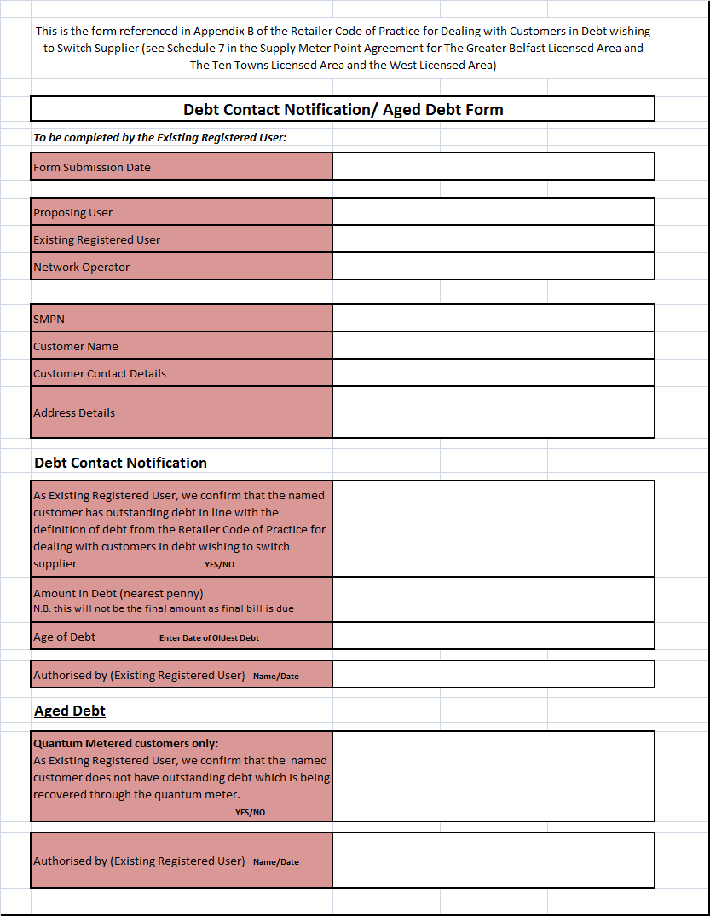

**Appendix C**

**Agreement to Assign Debt Sample Form**

Where the Proposing User has received a Debt Contact Notification Message from the Existing Registered User, both suppliers will adhere to this Code of Practice for sharing the required information on the customer with Debt for the sole purpose of achieving a smooth transfer to the Proposing User. It is recommended that the transfer of information between the parties will be conducted by e-mail within a response time of 3 working days of the request being made using the Agreement to Assign Debt Form

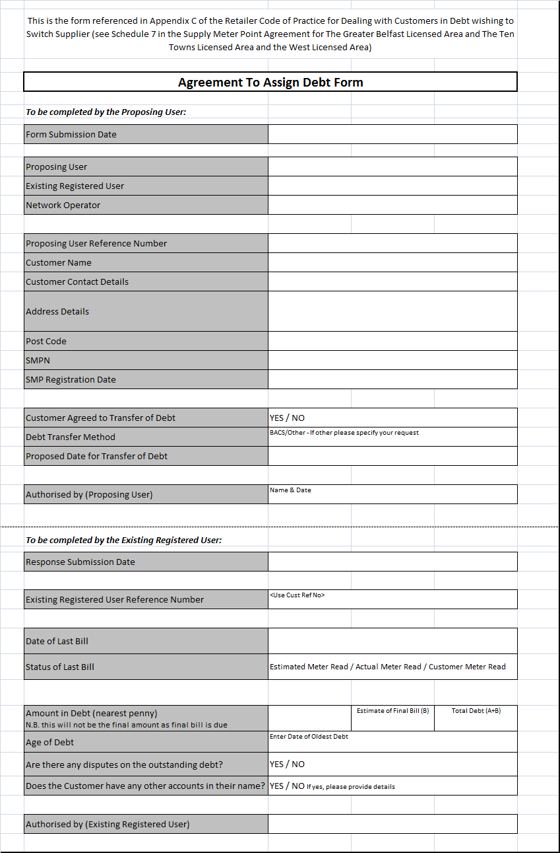

**Appendix D**

Mr Jones <Address Line 1> <Address Line 2> <City>

<County>

<Postcode>

Date<dd/mm/yyyy>

Dear Mr Jones,

Re: Customer ref XXXX Transfer of Debt

As per your instruction on <date>, I am pleased to inform you that your outstanding balance of £xxx was transferred to your new supplier as at <date>. This amount has been calculated on the basis that the meter readings provided are accurate. In the unlikely event that the meter reading provided are incorrect we will adjust your account accordingly and inform you of the new amount that will be transferred to your new supplier.

Please note that this is also the date on which responsibility for your gas supply will transfer to your new supplier.

I would like to take this opportunity to thank you for your valued custom.

Kind Regards,

<Name>

Withdrawing User

**Appendix E**

Mr Jones <Address Line 1> <Address Line 2> <City>

<County>

<Postcode>

Date<dd/mm/yyyy>

Dear Mr Jones,

REF: XXX

Dear Mr Jones,

We are very pleased that you have chosen to have your gas supplied by us. However, when we contacted your existing supplier to process the transfer they have advised us that a balance is overdue on your existing account. As a result we are unable to accept your application until this is resolved.

You need to contact your existing supplier and enter into a satisfactory payment arrangement or pay your account in full. If agreement is reached then transfer will take place. Failure to reach agreement will result in closure of this application 10 days from today’s date and you will remain with your existing supplier.

If you dispute this outcome you should contact your existing gas supplier who will investigate this on your behalf and provide further details.

If you would like any further help or advice regarding this matter, please call us on <TEL NUMBER>

Yours Sincerely,

<Name>

New Supplier

**Appendix F**

**Timescales for Transfer of Debt & Payment of Debt**

