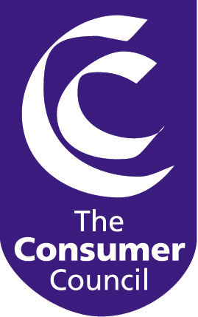
BY E-MAIL

Our ref: 3/3/1.09

31 October 2005

Lisa Mullan
Ofreg
Queens House
10-18 Queen Street
BELFAST BT1 6ED

Dear Ms Mullan

ENERGY EFFICIENCY: THE “MOST BEST” OPTIONS

The Consumer Council welcomes the opportunity to respond to the Northern Ireland Authority for Energy Regulation’s (NIAER) consultation paper, Energy Efficiency: The ‘Most Best’ Options. The paper sets out an extensive and wide-ranging number of recommended actions as the best way forward to reduce electricity consumption and CO2 emissions in Northern Ireland against UK and European targets.

The Consumer Council understands that as responsible consumers we must all increase our energy efficiency in order to reduce consumption and so cut CO2 emissions. However, the debate is much wider and encompasses issues such as the cost of investment in energy efficiency, the sources of funding for change, the payback (at both macro and micro levels) and the implications for current and future energy prices.

Given the importance of this subject matter – allied to the fact that the Consumer Council has not had an opportunity to discuss it with partners – we would recommend (indeed as the consultation document suggests) further debate, discussion and research. The Authority may wish to consider that the Fuel Poverty Advisory Group, as an existing forum for all of the key stakeholders, could be a useful arena in which to open and develop this debate.

The Consumer Council will be delighted to work with its partners in taking forward this important issue.

Yours sincerely

WESLEY HENDERSON
Director, Energy and Corporate Services

